Hello from the FSU Math System Group!

Your computer has received a required OS upgrade.

IMPORTANT:
On your first login, you will be presented with one or more question boxes like this:
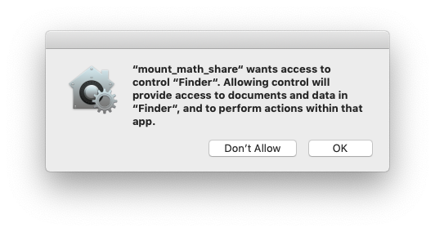

Please click the OK button for this or any other
question boxes that begin with "mount_math".

It should only happen once. If you have any problems, please email root@math.fsu.edu

Thank you!

