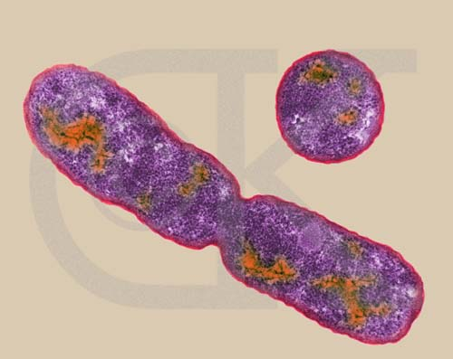
Activity 1: Modeling Bacteria Growth

Bacteria reproduce very fast. Given the right conditions, with enough food and space, they will double in a few minutes. Suppose there are initially 10,000 bacteria in a certain colony and they are doubling their population every half-hour.

- Make a table to show the growth of the colony for the next five (5) hours.

Time  ( in hours) | Number of Bacteria  (in 10,000s)
0.0 | 1
0.5 | 2
1.0
1.5
2.0
2.5
3.0
3.5
4.0
4.5
5.0

- Determine whether or not the following eight graphs are appropriate as representations of the bacteria growth versus time. Discuss the merits or faults of each graph and the usefulness of the information each provides about the bacteria.
Graph 1

Graph 2

Graph 3

Graph 4

Graph 5

Graph 6

Graph 7

Graph 8
Activity 2: The Growth of Water-Hyacinth

Starke Lake is a 200 acre lake in Orange County, Florida. Someone thought water-hyacinth was a pretty flower and he put some in Starke Lake. Today water-hyacinth covers one acre of Starke Lake. Research shows that the water-hyacinth population doubles in size every two weeks. You are a park ranger and it is your job to examine the effects of the water-hyacinth.

- Complete the following table.

Week | Acres of water- hyacinth | Fraction of Starke Lake covered by water-hyacinth | Fraction of Starke Lake free from water-hyacinth
0 | 1
2
4
6
8
10
n

2. Create a graph on graph paper that shows how the acres of water-hyacinth change over time. On another graph, plot the following graphs (using different colors): The fraction of Starke Lake covered by water-hyacinth versus weeks, and the fraction of Starke Lake free from water-hyacinth versus weeks.

- How long does it take for the flower to completely cover Starke Lake? Explain your response.

- When will the flower cover half of Starke Lake? Explain.

5. If Starke Lake was twice as big, how long would it take Starke Lake to be covered by water-hyacinths? Why?

