Computational Aeroacoustics:

An Overview of Computational Challenges and Applications

CHRISTOPHER K.W. TAM
Department of Mathematics
Florida State University
Tallahassee, FL 32306-4510
USA

Phone: 850-644-2455
Fax: 850-644-4053
Email: tam@math.fsu.edu

Computational Aeroacoustics:

An Overview of Computational Challenges and Applications

CHRISTOPHER K.W. TAM

Department of Mathematics, Florida State University, Tallahassee, FL 32306-4510, USA

The objective of this paper is to present an overview of recent advances in Computational Aeroacoustics (CAA). During the last decade, CAA has developed quite independent of Computational Fluid Dynamics (CFD). There are computational issues that are unique to CAA and are, generally, not considered in CFD. In this paper, these issues are discussed and explained. In CAA, there is a great need to resolve high frequency short waves with the minimum number of mesh points per wavelength. There is also a special need to minimize numerical dispersion and dissipation associated with wave propagation computation. All these have led to the development of large-stencil high-resolution schemes for CAA. A careful examination of dispersion and dissipation errors due to spatial and temporal discretization is provided. These errors are quantified and analyzed in wave number space through the use of Fourier-Laplace transforms. At this time, some of the original computational challenges to CAA have been resolved satisfactorily. A discussion of how some of these computational issues are resolved is presented. Several important CAA applications with interesting or unusual computational innovations are highlighted. Finally, a few of the most pressing outstanding computational challenges to CAA are elaborated.

Keywords: Computational Aeroacoustics; high resolution schemes; wave number analysis; dispersion and dissipation errors.

1. INTRODUCTION

Relative to Computational Fluid Dynamics (CFD), Computational Aeroacoustics (CAA) is a young research area. It began in earnest about ten years ago. During this decade, CAA algorithms have developed rapidly. These methods soon found applications in many areas of aeroacoustics.
The purpose of this special issue of IJCFD is to provide an up-to-date review of the status of CAA. The review is divided into two parts. The first part is a review of CAA methodology. The second part is a review of CAA applications.
On the methodology side, computational issues relevant to CAA algorithms as well as numerical boundary treatments including radiation, outflow, absorbing and time domain impedance boundary conditions are examined (Kurbatskii & Mankbadi, 2004; Hixon, 2004; Hu, 2004; Fung & Ju, 2004 in this issue). Extensive references on the subject matter are provided in each article. In addition, the implementation of CAA algorithms using parallel computing is also reviewed (Long et al., 2004).
The objective of CAA is not just to develop computational methods but also to use these methods to solve real practical aeroacoustic problems. It is also a goal of CAA to perform direct numerical simulation or similar simulations of aeroacoustic phenomena so as to allow an investigator to determine what the noise generation mechanisms and sound propagation processes are and to obtain a better understanding of the physics of the problem. In relation to these objectives four areas of CAA applications are reviewed. They include jet noise (Bailly & Bogey, 2004) fan noise (Envia et al., 2004), airframe noise (Singer & Guo, 2004) and cavity noise (Takeda & Shieh, 2004). It will become clear upon reading the articles on these subjects that there is not a uniform degree of maturity. In some application areas, CAA has become an important component of noise prediction schemes. Further, in these areas, CAA simulations have made significant progress in advancing our present day understanding of the physics and mechanisms of noise generation and dissipation. In other areas, the potential for CAA applications is there but advances are still awaiting.
All the articles in this special issue are written by the top experts of the field. To each of them, a special gratitude is owed for contributing freely their time and effort.
There have been a number of review articles on CAA written during recent years by Tam (1995a, 1998), Lele (1997), Wells & Renaut (1997) and others. These articles pointed out some of the computational issues that set CAA apart from CFD. The reason why CAA faces a different set of computational challenges is the fact that aeroacoustics problems are by nature very different from standard aerodynamics and fluid mechanics problems. Aeroacoustics problems, by definition, are time dependent, whereas aerodynamics and fluid mechanics problems are, generally, time independent or involve only low frequency unsteadiness. Below is a list of some of the major computational challenges facing CAA.
a. Aeroacoustics problems typically involve frequency range that spreads over a wide bandwidth. Numerical resolution of the high frequency waves with extremely short wavelength becomes a formidable obstacle to accurate numerical simulation.
b. Acoustic waves usually have small amplitudes. They are very small compared to the mean flow. Oftentimes, the sound intensity is five to six orders smaller. To compute sound waves accurately, a numerical scheme must have extremely low numerical noise.
c. In most aeroacoustics problems, interest is in the sound waves radiated to the far field. This requires a solution that is uniformly valid from the source region all the way to the measurement point at many acoustic wavelengths away. Because of the long propagation distance, computational aeroacoustics schemes must have minimal numerical dispersion and dissipation. Also, it should propagate the waves at the correct wave speeds and is isotropic irrespective of the orientation of the computation mesh.
d. Computation domain is inevitably finite in size. For aerodynamics or fluid mechanics problems, flow disturbances, generally, tend to decay very fast away from a body or their source of generation. They, therefore, are usually small at the boundary of the computation domain. Acoustic waves, on the other hand, decay very slowly and actually reach the boundaries of a finite computation domain. To avoid the reflection of outgoing sound waves back into the computation domain and thus contaminates the solution, radiation and outflow boundary conditions must be imposed at the artificial exterior boundaries to assist the waves to exit smoothly. For standard computational fluid dynamics (CFD) problems, such boundary conditions are usually not required.
e. Aeroacoustics problems are archetypical examples of multiple-scales problems. The length scale of the acoustic source is usually very different from the acoustic wavelength. That is, the length scale of the source region and that of the acoustic far field region can be vastly different. Computational aeroacoustic methods must be designed to deal with problems with greatly different length scales in different parts of the computational domain,
It should be clear, as elaborated above, that the nature of aeroacoustics problems is substantially different from those of traditional fluid dynamics and aerodynamics problems. To be able to compute or simulate aeroacoustics problems accurately and efficiently, standard CFD schemes, designed for applications to fluid mechanics problems, are generally not adequate. For this reason, there is a need for an independent development of CAA. This was what happened in the last ten years. During this period, steady advances have been made both in the development of CAA methodology and in their applications to real world problems.
To simulate an aeroacoustic phenomenon or problem computationally, the numerical algorithm must consist of several basic elements. They are:
(i) A time marching computation scheme.
(ii) A suitably designed computation grid.
(iii) An artificial selective damping algorithm or filtering procedure if the marching scheme has no built-in artificial selective damping.
(iv) A set of radiation/outflow numerical treatments for use at the boundaries of the computation domain.
A good quality time marching scheme is basic to any computation effort. Artificial selective damping or a filtering procedure is essential to eliminating spurious numerical waves that could contaminate the computed solution. Also such damping terms can often help to suppress numerical instabilities at the boundaries of the computation domain or at surfaces of discontinuities such as mesh-size-change interfaces or solid wall surfaces. Numerical boundary treatments serve two basic purposes. First, they are to allow outgoing waves to leave the computation domain with little reflection. Second, they are to reproduce all the effects of the outside world on the computation domain. For instance, if there is incoming acoustic and vorticity wave or there is an inflow, they are to be generated by the numerical boundary conditions.
In this paper, an overview and discussion of computational issues and methods beyond what are covered and addressed by the four methodology articles of this special issue are provided. In addition, several successful applications of CAA methods to aeroacoustic problems that are outside the scope of the application articles will be highlighted.

2. DISCRETIZED COMPUTATION SCHEME AS DISPERSIVE WAVES

Acoustics are governed by the compressible Navier-Stokes equations. In most cases, molecular viscosity is unimportant so that the use of Euler equations is sufficient. In solving the Navier-Stokes or Euler equations computationally, the first step is to perform discretized approximation to the spatial and temporal derivatives. Once this is done, one must recognize that the solutions of the discretized equations are not the same as those of the original partial differential equations. A central effort of CAA is to understand mathematically the behavior of the solution of the discretized equations and to quantify and minimize the error. Here error is referred to as the difference between the solution of the original partial differential equations and the discretized system.
Invariably, the discretized equations behave mathematically like a dispersive wave system (Vichnevetsky & Bowles, 1982; Trefethen, 1982; Tam & Webb, 1993), even though the waves supported by the original partial differential equations are nondispersive. This is an extremely important point and should be clearly understood by all CAA investigators and users. Let us illustrate this by considering the solution of the simple convective wave equation,
$\frac{¶u}{¶t}+c\frac{¶u}{¶x}=0$ (1)
and initial condition
$t=0 u\left(x,0\right)=F\left(x\right)\text{.}$
To find the nature of the waves supported by this equation, we may perform a Fourier-Laplace transform to this equation. The Fourier transform of a function $f(x)$, denoted by $\hat{f}(α)$, and its inverse are defined by
The Laplace transform of a function $g(t)$, denoted by $\bar{g}(w)$, and its inverse are defined by
where $α$ and $w$ are the wave number (Fourier transform variable) and angular frequency (Laplace transform variable). $G$ is a contour in the upper half $w$-plane parallel to the real axis, above all poles and singularities of $\bar{g}(w)$.
The Fourier-Laplace transform of (1) leads to,
$\left(w−cα\right)\tilde{u}=\frac{i\hat{F}\left(α\right)}{2p}$ (2)
where $\tilde{u}$ is the Fourier-Laplace transform of $u$. $\hat{F}(α)$ is the Fourier transform of initial condition $u(x,0)$. Thus $\tilde{u}$ is given by,
$\tilde{u}=\frac{i\hat{F}\left(α\right)}{2p\left(w−cα\right)}$. (3)
The poles of (3) are found by setting the denominator to zero. This yields,
$w=cα$. (4)
(4) gives the relationship between wave number and angular frequency. It is called the dispersion relation. According to dispersive wave theory (Whitham, 1974), all wave propagation characteristics of the partial differential equation are encoded in the dispersion relation. The group velocity or wave speed is given by ${dw}/{dα}$. In the case of equation (1), by using dispersion relation (4), the group velocity is,
$\frac{dw}{dα}=c$ (5)
so that all wave components propagate with the same speed. That is to say, the waves supported by the convective wave equation are nondispersive.

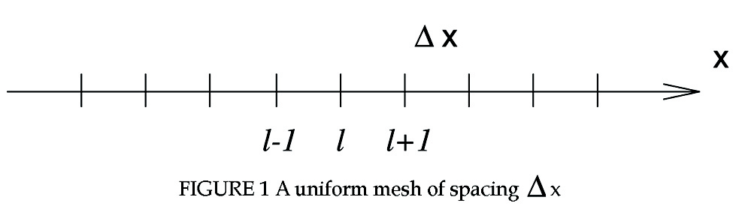

Now we may convert (1) into a discretized system on a uniform mesh as shown in Fig. 1 by first approximating the $x$-derivative at the $l^{\text{th}}$ mesh point by a standard central difference quotient or by the DRP scheme (Tam & Webb, 1993) with a stencil of $\left(2N+1\right)$ points; i.e.,
${\left(\frac{¶u}{¶x}\right)}_{l}@\frac{1}{Dx}\sum_{j\text{=-}N}^{N}{a_{j}u_{l+j}; \left(a_{j}\text{=-}a_{−j}\right)}$. (6)
(6) is a relationship for a set of discrete mesh points on the $x$-axis (see Fig. 1). We may now generalize this relationship and regard it to hold true for any set of points spaced at $Dx$ apart on the $x$-axis. This generalizes (6) to
$\frac{¶u}{¶x}\left(x\right)@\frac{1}{Dx}\sum_{j\text{=-}N}^{N}{a_{j}u\left(x+jDx\right)}$. (7)
In (7) $x$ is an arbitrary point on the $x$-axis. By setting $x=x_{l}$ in (7) Eq. (6) is recovered. (7) is a finite difference relation of a continuous variable. By taking the Fourier transform of (7) it is straightforward to find with the help of the Shifting Theorem,
$iα\hat{u}@i\bar{α}\hat{u}$ (8)
where
$\bar{α}=\frac{−i}{Dx}\sum_{j\text{=-}N}^{N}{a_{j}e^{\text{ij}αDx}}=\frac{2}{Dx}\sum_{j=1}^{N}{a_{j}\text{sin}\left(αDx\right)}$. (9)
The $α$ on the left side of (8) is the wave number arising from the transform of the $x$-derivative. The $\bar{α}$ on the right side may, therefore, be interpreted as the wave number of the finite difference scheme. It is to be noted that for central difference approximation $\bar{α}$ is real when $α$ is real.
Once the $a_{j}$’s are known, the relationship between $α$, the true wave number, and $\bar{α}$, the wave number of the finite difference scheme, may be calculated by (9). For the standard central difference schemes, the $a_{j}$’s are determined by using truncated Taylor series expansion for the terms on the right side of (6). For the DRP scheme of Tam & Webb (1993), the $a_{j}$’s are found by minimizing the square of the difference between $\bar{α}Dx$ and $αDx$ over a large band of wave numbers; i.e., minimizing $E=\int{|\bar{α}Dx−αDx|^{2}}d(αDx)$. Figure 2 shows the dependence of $\bar{α}Dx$ on $αDx$ over the interval $−p≤αDx≤p$ for the standard 6th order central difference scheme, the 7-point stencil and the 15-point stencil DRP schemes. The coefficients of the 15-point stencil DRP scheme are given in the appendix. For low wave numbers, $\bar{α}Dx$ is nearly equal to $αDx$. For instance, for the 7-point stencil DRP scheme, $\bar{α}Dx$ differs from $αDx$ by less than 0.1% in the interval $0≤|αDx|≤1\text{.}\text{05}$. That is, this scheme incurs an error of less than 0.1% when 6 mesh points per wavelength is used in a computation.

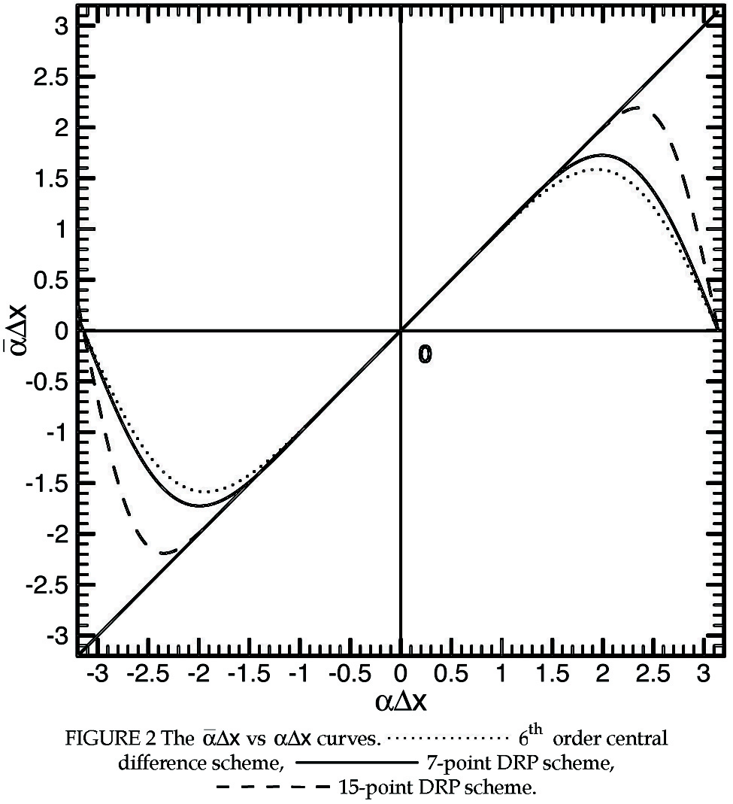

Suppose an unsymmetric stencil with $N$ points to the left and $M$ points to the right is used to approximate the $x$-derivative; i.e.,
${\left(\frac{¶u}{¶x}\right)}_{l}@\frac{1}{Dx}\sum_{j\text{=-}N}^{M}{a_{j}u_{l+j}, N¹M}$. (10)
It is easy to find by taking the Fourier transform of the generalized form of (10) that the corresponding wave number relationship between $\bar{α}Dx$ and $αDx$ is
$\bar{α}Dx\text{=-}i\sum_{j\text{=-}N}^{M}{a_{j}e^{\text{ij}αDx}}$. (11)
We note that for real $α$, $\bar{α}$ is complex. The significance of stencil wave number $\bar{α}$ being complex will be discussed later.
Now after performing spatial discretization, (1) may be rewritten in the form,

$\frac{{\text{du}}_{l}}{\text{dt}}=K_{l}$ (12a)
$K_{l}=\frac{−c}{Dx}\sum_{j\text{=-}N}^{N}{a_{j}u_{l+j}}$. (12b)

The time derivative of (12a) may be approximated by either a single step method such as the Runge-Kutta method or by a multi-step method such as the Adams-Bashforth 4-level scheme. We will first consider multi-step method. In this case $u^{(n)}$, where superscript $n$ denotes the time level, is advanced to the $(n+1)$ time level by the formula

$u_{l}^{\left(n+1\right)}=u_{l}^{\left(n\right)}+Dt\sum_{j=0}^{3}{b_{j}K_{l}^{(n−j)}}$. (13)

$Dt$ is the time step. $b_{j}$’s are the coefficients of the scheme. Finite difference equation (13) may now be generalized to one with a continuous variable following the same steps that lead to (7). We may apply Laplace transform to the generalized form of (13). On recalling that $K_{l}(t)$ is ${\text{du}}_{l}(t)/{\text{dt}}$ and that the Laplace transform of ${{\text{du}}_{l}}/{\text{dt}}$ is $−iw{\bar{u}}_{l}$, it is straightforward to obtain, assuming zero initial condition, (see Tam & Webb, 1993, for details)
$−iw{\bar{u}}_{l}\text{@-}i\bar{w}{\bar{u}}_{l}$ (14)
where $\bar{w}$ is given by
$\bar{w}Dt=i\frac{\left(e^{−iwDt}−1\right)}{\sum_{j=0}^{3}{b_{j}e^{\text{ij}wDt}}}$. (15)
Since $w$ on the left side of (14) is the angular frequency of the Laplace transform of $d/{\text{dt}}$, $\bar{w}$ on the right side may be regarded as the angular frequency of the 4-level time matching scheme (13). It is easy to show numerically that $\bar{w}Dt$ is a good approximation of $wDt$ for small $wDt$. For the DRP scheme, the coefficients $b_{j}$ of (13) are chosen to minimize the difference between $\bar{w}Dt$ and $wDt$ over a band of $wDt$. Tam & Webb (1993) found that $\bar{w}@w$ to a high degree of accuracy for $wDt≤0\text{.}\text{19}$.
Now (1) may be fully discretized by first rewriting it as a system of two equations each involving only either temporal or spatial derivative

$\frac{¶u}{¶t}=K$
$K\text{=-}c\frac{¶u}{¶x}$.

The derivative of each of the above equation may be discretized according to (6) for spatial derivatives and (13) for time derivative. The fully discretized form of (1) is,
$K_{l}^{(n)}\text{=-}\frac{c}{Dx}\sum_{j\text{=-}N}^{N}{a_{j}u_{l+j}^{(n)}}$ (16a)
$u_{l}^{\left(n+1\right)}=u_{l}^{\left(n\right)}+Dt\sum_{j=0}^{3}{b_{j}K_{l}^{\left(n−j\right)}}$. (16b)
This set of finite difference equations with discrete variables $l$ and $n$ may again be generalized into a set of finite difference equations with continuous variables $x$ and $t$. By taking the Fourier-Laplace transform and after some algebra, it is easy to find that the solution is (see Tam & Webb, 1993, for treatment of initial condition),
$\tilde{u}=\frac{i\hat{F}\left(α\right)}{2p\left(\bar{w}−c\bar{α}\right)}\left(\frac{\bar{w}}{w}\right)$ (17)
where $\tilde{u}$ is the Fourier-Laplace transform of the solution of (16). (17) is identical to the Fourier-Laplace transform of the solution of the original convective wave equation; i.e., (3), if $\bar{w}$ and $\bar{α}$ in (17) are replaced by $w$ and $α$. The dispersion relation of the waves supported by (16) is given by the zeros of the denominator of (17), namely,
$\bar{w}\left(w\right)=c\bar{α}\left(α\right)$. (18)
This is formally the same as the dispersion relation of the original partial differential equation; i.e., (4), provided $\bar{w}$ is replaced by $w$ and $\bar{α}$ is replaced by $α$. It can be shown (see Tam & Webb, 1993) that the above discretized procedure will always lead to a formal preservation of the dispersion relation even for multi-dimensional problems governed by the linearized Euler equations. For this reason, the scheme is referred to as dispersion-relation-preservation (DRP). Since $\bar{w}@w$ and $\bar{α}@α$ are true for small $wDt$ and $αDx$, the dispersion relation of (16) is a good approximation of that of (1). This guarantees that the solution of finite difference equation (16) should be a good approximation of the exact solution if the solution contains only low frequency or long waves (we will refer this as the resolved wave number range). Outside the resolved wave number range, the dispersion relation of the discretized equation is no longer a good approximation of that of the original equation. As a result, the finite difference solution will differ significantly from the exact solution.
Now even in the resolved wave number range, the group velocity ${dw}/{dα}$ of dispersion relation (18) is not a constant equal to $c$. The waves supported by the finite difference approximation is dispersive. This turns out to be a general property of almost all discretized approximations. On the other hand, we now know the Fourier-Laplace transform of the exact solution of the finite difference approximation. This allows us to analyze quantitatively the various types of errors introduced by finite difference approximation. With such understanding and knowledge of the errors incurred, we are in a position to tailor the computational algorithm to meet the accuracy needed by the physical problem.

2.1. Origin of Numerical Dispersion

The exact solution of the finite difference approximation of (1) using the DRP scheme is given by the inverse transform of (17),

$u\left(x,t\right)=\frac{i}{2p}\int_{\text{-¥}}^{¥}{\int_{G}{\frac{\hat{F}\left(α\right)}{\left(\bar{w}−c\bar{α}\right)}}}\frac{\bar{w}}{w}e^{i\left(αx−wt\right)}dwdα$. (19)

The double integral may be evaluated by first calculating the contributions of the poles in the $w$-plane. The poles are given by the zeros of the denominator of the integrand, that is, the roots of,

$\bar{w}\left(w\right)=c\bar{α}\left(α\right)$. (20a)

(20a) is the dispersion relation; same as (18). For a four level time marching scheme, there would be four poles; $w=w_{j}(α)$, $j=1,2,3,4$. One of the poles has $\text{Im}(w)$ nearly equal to zero. This is the pole that corresponds to the physical solution. The other poles lead to solutions that are heavily damped.
Numerical dispersion can arise from spatial or temporal discretization. We will first consider spatial discretization alone. For this purpose, we will let $Dt→0$, that is, we treat time exactly. This is equivalent to replacing $\bar{w}$ by $w$ in (19) so that the expression for the exact solution of the spatially discretized equation (1) is,

$u\left(x,t\right)=\frac{i}{2p}\int_{\text{-¥}}^{¥}{\int_{G}{\frac{\hat{F}\left(α\right)}{w−c\bar{α}\left(α\right)}}}e^{i\left(αx−wt\right)}dwdα$.

Dispersion relation (20a) now simplifies to
$w=c\bar{α}\left(α\right)$. (20b)
The integrand has a pole at $w=c\bar{α}(α)$. On deforming the inverse contour $G$ to pick up this pole in the $w$-plane, it is easy to find through the use of the Residue Theorem
$u\left(x,t\right)=\int_{\text{-¥}}^{¥}{\hat{F}\left(α\right)}e^{i\left(α\frac{x}{t}−w\right)t}|_{w=c\bar{α}\left(α\right)}dα$. (21)
Now for large $t$ (with $x/t$ fixed), the $α$-integral of (21) may be evaluated by the method of stationary phase (see e.g., Ablowitz & Fokas, Chapter 6). The stationary phase point $α=α_{s}$ is given by the zero of the derivative of the phase function $Y=(α(x/t)−w(α))$ with respect to $α$. This leads to
$\frac{dw}{dα}=c\frac{d\bar{α}\left(α\right)}{dα}|_{α=α_{s}}=\frac{x}{t}$, (22)
which yields $α_{s}$ as a function of $x/t$. The asymptotic solution is
$\underset{t→¥}{u\left(x,t\right)}\text{\sim }{\left(\frac{2p}{\left|c{\bar{α}}^{''}\left(α_{s}\right)\right|t}\right)}^{\frac{1}{2}}\hat{F}\left(α_{s}\right)e^{i\left[α_{s}\frac{x}{t}−c\bar{α}\left(α_{s}\right)\right]t+i\frac{p}{4}\text{sgn}\left(−c{\bar{α}}^{''}\right)}$ (23)

where $\text{sgn}(z)$ is the sign of $z$.
In wave propagation theory (Whitham, 1974) ${dw}/{dα}$ in (22) is called the group velocity. Since $x=({dw}/{dα})t$, it is the propagation speed of the component of the solution with wave number $α$ in the $x−t$ diagram. Now $w$ and $α$ are related by (20b). In general $d{\bar{α}}/{dα}$ is not a constant equal to 1, different wave number of the initial disturbances will propagate with a slightly different speed. Because of the different propagation speed a wave packet will spread out or disperse in space as it propagates. Even a small difference in group velocity can manifest into serious dispersion over a long time or a long distance of propagation. This is the origin of numerical dispersion.
In the more general case of solution (19), when both spatial and temporal discretization are used, the group velocity may be calculated by implicit differentiation of (20a). This gives,
$\frac{dw}{dα}=\frac{c\frac{d\bar{α}}{dα}}{\frac{d\bar{w}}{dw}}$. (24)
(24) indicates that numerical dispersion can be the result of imperfect spatial discretization; i.e., $d{\bar{α}}/{dα}¹1$ or imperfect temporal discretization; i.e., $d{\bar{w}}/{dw}¹1$. We will defer the consideration of imperfect time discretization later as it is quite involved. We will now illustrate the effect of dispersion due to spatial discretization by a numerical example.
For the convective wave equation (1), (22) reveals that the variation in group velocity is caused by the variation of the slope of the $\bar{α}Dx$ versus $αDx$ curve. Figure 3 shows the $d{\bar{α}}/{dα}$ versus $αDx$ curves for a number of schemes. Notice that the $d{\bar{α}}/{dα}$ curve for the 7-point stencil DRP scheme has a peak at $αDx=0\text{.}\text{67}$ at which $d{\bar{α}}/{dα}=1\text{.}\text{00276}$. That is, the wave component with $αDx=0\text{.}\text{67}$ (wave with 9.38 mesh points per wavelength) will propagate faster than the exact wave speed $d{\bar{α}}/{dα}=1\text{.}0$ by about 0.3%. Suppose in a computation, the waves propagate over a distance of 400 mesh points. In this case, when the main part of the wave packet reaches $x=\text{400}$, the wave component with $αDx=0\text{.}\text{67}$ will reach $x=\text{401}\text{.}1$. Under these circumstances, numerical dispersion would just be noticeable as wave dispersion exceeds one mesh point. On the other hand, if the standard 6th order scheme is used instead, severe numerical dispersion will result when the main wave reaches $x=\text{400}$. Waves in the wave number range of $αDx>0\text{.}6$, having group velocity less than 1.0 would form trailing waves.

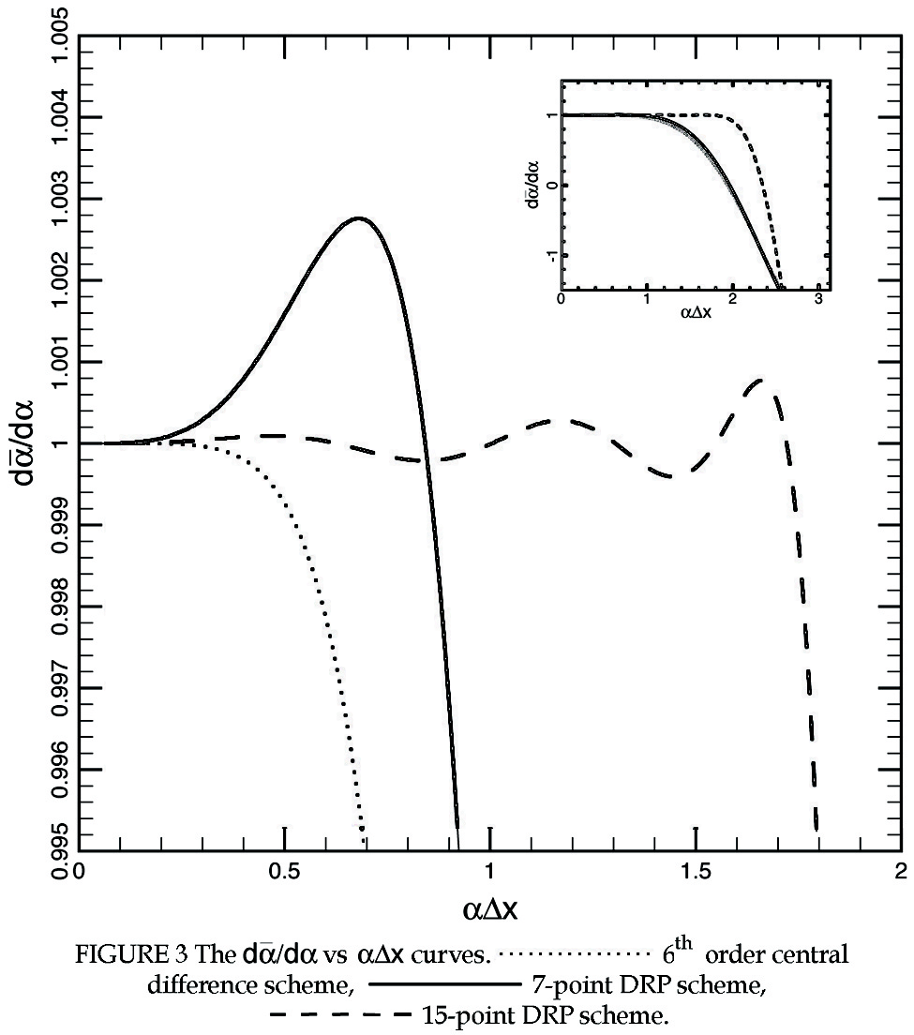
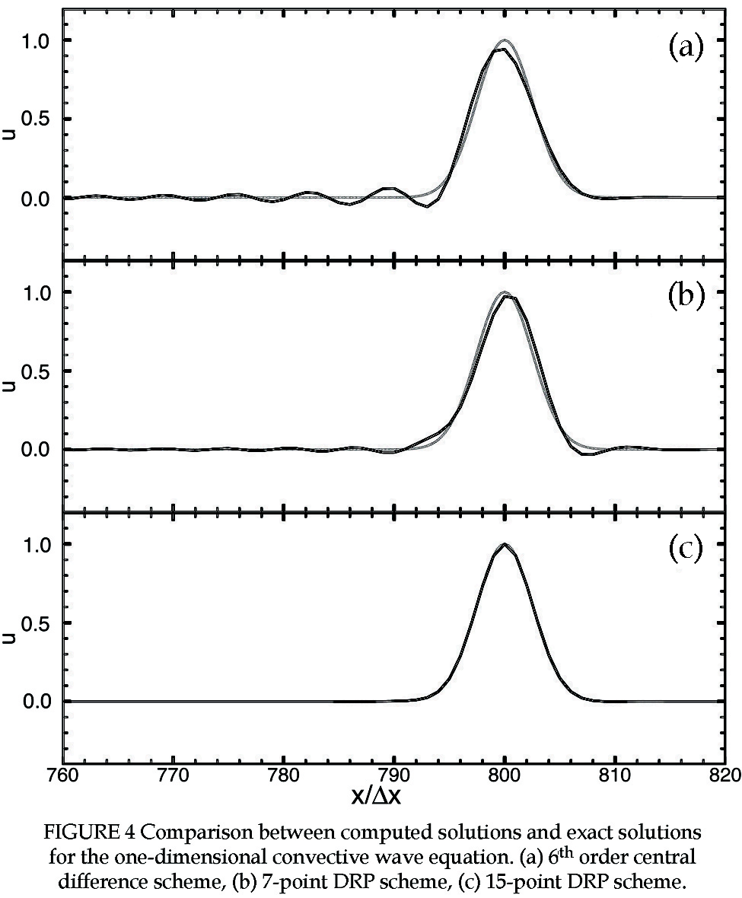
A relevant question to ask is how to reduce numerical dispersion due to spatial discretization. This can be done by using a scheme with a larger stencil. Figure 3 shows the $d{\bar{α}}/{dα}$ curve for the 15-point stencil DRP scheme. For $αDx<1\text{.}\text{73}$, the group velocity differs from 1.0 by no more than 0.1%. Thus if the wave packet of the solution contains only waves with wave number $αDx<1\text{.}\text{73}$, then there will be no observable numerical dispersion even after the wave packet propagates over a distance of up to 1000 mesh points. As a concrete example, Fig. 4 shows the computed solution of the convective wave equation (1) with initial condition in the form of a Gaussian with a half-width of 3 mesh spacings,
$u\left(x,0\right)=e^{−\left(\text{ln}2\right){\left(\frac{x}{3Dx}\right)}^{2}}$ (25)
using the standard 6th order scheme, the 7-point stencil and the 15-point stencil DRP scheme. It is easy to see that there is significant numerical dispersion (with extensive trailing waves) when computed by the standard 6th order scheme. The 7-point stencil DRP scheme is better. Both schemes, having the same stencil size, require the same amount of computation. The solution by the 15-point stencil is even better. For all intents and purposes, the solution is identical numerically to the exact solution.
It is worthwhile to point out that numerical dispersion is the result of the variation of the group velocity of a numerical scheme. Unfortunately, in some textbooks it is linked erroneously to the phase velocity of the computation scheme. Phase velocity and group velocity are not the same. In fact, they can have opposite signs so that phase velocity and group velocity can propagate in opposite directions. From Fig. 3, it is easy to see that $d{\bar{α}}/{dα}$ for the standard 6th order central difference scheme as well as the 7-point stencil DRP scheme is negative for $αDx>2\text{.}0$. In other words, for short waves with $αDx>2\text{.}0$, the phase velocity is positive but the waves propagate backward because the group velocity is negative.

2.2. Numerical Dispersion Arising from Temporal Discretization

As was pointed out in the last section, computation schemes that have dispersion-relation-preserving property will exhibit numerical dispersion due to temporal discretization if $d{\bar{w}}/{dw}$ of the angular frequency relationship $\bar{w}(w)$ is not equal to 1.0. Most single time step schemes, such as the Runge-Kutta method, do not have dispersion-relation-preserving property. However, they do lead to numerical dispersion. For schemes of this type, there is no general way to derive the dispersion relation. To illustrate this point, let us again consider numerical solution of convective wave equation (1) by finite difference. We will use a 15-point stencil DRP scheme to approximate the spatial derivative. This spatial scheme can accurately resolve waves with as few as 3.6 mesh points per wavelength so that unless an acoustic pulse has extremely narrow half-width, there is negligible dispersion due to spatial discretization. The Fourier transform of the discretized form of (1) is,
$\frac{d\hat{u}}{\text{dt}}=f\left(\hat{u}\right)$ (26a)
where $f\left(\hat{u}\right)\text{=-}\text{ic \{}\bar{α}\left(α\right)\hat{u}$. (26b)
Now suppose we discretize the time derivative of (26) by the 4th order Runge-Kutta scheme with time step $Dt$. The time marching scheme is,

$\begin{matrix}K_{1} & & f\left({\hat{u}}^{(n)}\right)Dt \\ K_{2} & & f\left({\hat{u}}^{(n)}+β_{2}K_{1}\right)Dt \\ K_{3} & & f\left({\hat{u}}^{(n)}+β_{3}K_{2}\right)Dt \\ K_{4} & & f\left({\hat{u}}^{(n)}+β_{4}K_{3}\right)Dt\end{matrix}$
${\hat{u}}^{\left(n+1\right)}={\hat{u}}^{\left(n\right)}+\sum_{j=1}^{4}{w_{j}K_{j}}$. (27)
For the standard 4th order Runge-Kutta scheme, the constants are assigned the following values
$β_{2}=β_{3}=\frac{1}{2}, β_{4}=1\text{.}0, w_{1}=w_{4}=\frac{1}{6}, w_{2}=w_{3}=\frac{1}{3}$.
Substitution of (26b) into (27), the time marching finite difference equation for ${\tilde{u}}^{(n)}$ is found to be,
${\hat{u}}^{\left(n+1\right)}={\hat{u}}^{\left(n\right)}\left[1+\sum_{j=1}^{4}{c_{j}{\left(−\text{ic \{}\bar{α} | | Dt\right)}^{j}}\right]$ (28)
where
$\begin{aligned}c_{1}=\sum_{j=1}^{4}{w_{j}}, c_{2}=\sum_{j=2}^{4}{w_{j}}β_{j}, \\ c_{3}=w_{3}β_{3}β_{2}+w_{4}β_{4}β_{3}, c_{4}=w_{4}β_{4}β_{3}β_{2}\end{aligned}$. (29)

It is a simple matter to show that for the Standard RK scheme $c_{j}=1/j!$. Recently Hu et al. (1996) proposed to take $c_{1}=1\text{.}0$, $c_{2}=0\text{.}5$, $c_{3}=0\text{.}\text{162997}$, $c_{4}=0\text{.}\text{0407574}$ based on wave propagation consideration. They called their scheme the low-dissipation low-dispersion Runge-Kutta (LDDRK) scheme. We will discuss their reasoning later. This scheme is quite widely used in CAA.
Now (28) can be readily generalized into a finite difference equation with a continuous variable. By applying Laplace transform to the difference equation, it is easy to find that the dispersion relation of the finite difference algorithm of the convective wave equation discretized temporally by a 4th order Runge-Kutta scheme is,
$e^{−iwDt}=\left[1+\sum_{j=1}^{4}{c_{j}{\left(−\text{ic \{}\bar{α} | | Dt\right)}^{j}}\right]$. (30)
By differentiating (30) with respect to $α$, the following formula for the group velocity is derived,
$\frac{dw}{dα}=\frac{c\sum_{j=1}^{4}{{\text{jc}}_{j}{\left(−\text{ic \{}\bar{α} | | Dt\right)}^{j−1}}}{\left[1+\sum_{j=1}^{4}{c_{j}{\left(−\text{ic \{}\bar{α} | | Dt\right)}^{j}}\right]}\frac{d\bar{α}}{dα}$. (31)
Since $dw/dα$ is not a constant equal to c even if $d{\bar{α}}/{dα}=1\text{.}0$, numerical dispersion is introduced by the use of the Runge-Kutta scheme. A plot of $\text{Re}({dw}/{dα})$ as a function of $cαDt$ ($\bar{α}=α$ assumed) for the LDD Runge-Kutta scheme of Hu et al. (1996) is given as one of the curves in Fig. 6. Notice that the group velocity drops below $c$ for $cαDt>0\text{.}5$. The group velocity is less than the exact wave speed by 0.2% or more for $cαDt>0\text{.}\text{65}$. Waves in this range will form trailing waves after propagating over a distance of approximately 600 mesh points.

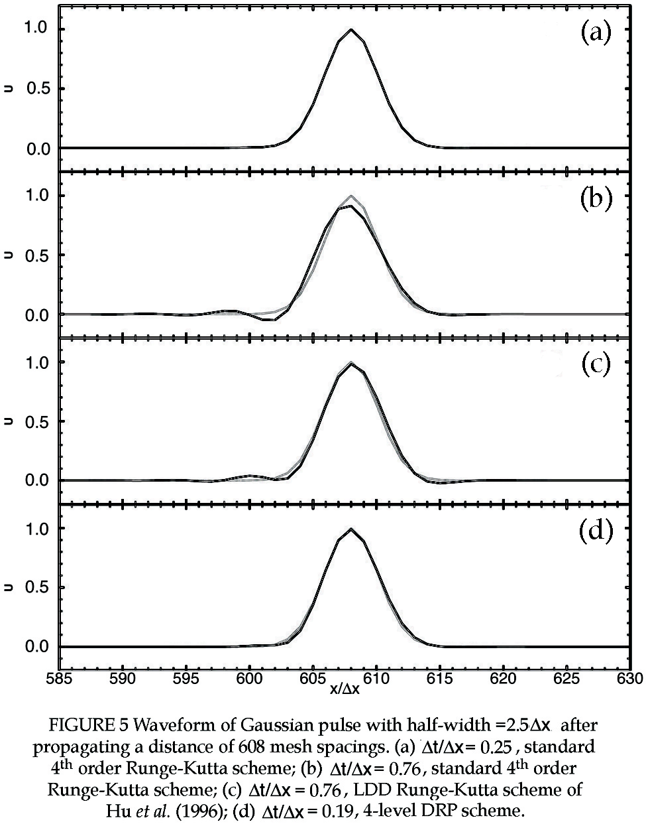
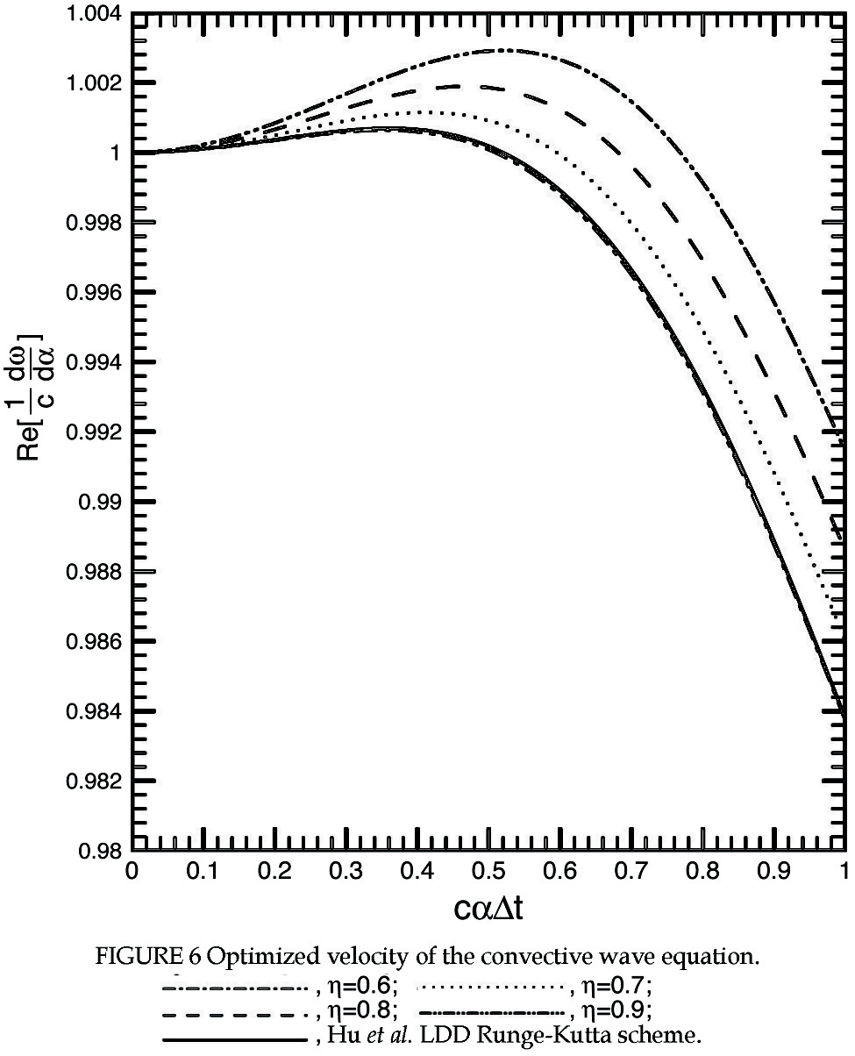

To illustrate numerical dispersion due to temporal discretization, we will consider the solution of (1) with initial condition,
$t=0,\text{ u}\left(\text{x,0}\right)=\text{exp}\left[−\left(\text{ln}2\right){\left(\frac{x}{2\text{.}5Dx}\right)}^{2}\right]$ (32)
using the 15-point stencil DRP scheme for spatial discretization and the standard 4th order Runge-Kutta scheme for temporal discretization. For convenience, we will set $c=1$. The computed results are shown in Fig. 5. Figure 5a shows the computed waveform after the pulse has propagated a distance of 608 mesh spacings using a very small time step $Dt=0\text{.}\text{25}Dx$. The computed result is indistinguishable from the exact solution. Figure 5b shows the computed result when a larger $Dt$, $Dt=0\text{.}\text{76}Dx$ is used. There is no question that the pulse is slightly dispersed. The cause is temporal discretization. For comparison purpose, Fig. 5c shows the computed waveform using the LDD Runge-Kutta scheme of Hu et al. (1996) with $Dt=0\text{.}\text{76}Dx$. There is definitely an improvement using this scheme. However, there are still some trailing waves, a manifestation of numerical dispersion. For initial condition (32), a small fraction of the initial pulse has wave number larger than $αDx=0\text{.}\text{855}$ corresponding to $αDt=0\text{.}\text{65}$. This part of the initial spectrum will propagate slower according to the group velocity curve of Fig. 6. They show up as trailing waves. Finally, Fig. 5d shows the computed result of the 4-level time marching DRP scheme of Tam & Webb (1993). The 4-level scheme computes the derivative function once per step. The single step Runge-Kutta scheme computes the derivative function four times per step. Thus to compare the results based on nearly the same workload, the time step of the DRP is taken to be a quarter of that of the Runge-Kutta schemes; i.e., $Dt=0\text{.}\text{19}Dx$. As can be seen, the results of Fig. 5b, 5c and 5d seem to indicate that the DRP scheme has less dispersion due to temporal discretization.
At the present time, there is no question that the Runge-Kutta scheme is the most popular time discretization method. In the literature, many articles can be found proposing some slight modifications to the original formulation to reduce storage requirement or to improve computing time or to improve accuracy. Most of the proposals were strictly on time marching without considering linkage to spatial discretization as is necessary in wave propagation problems. Hu et al. (1996) appear to be the first to optimize the constants of the Runge-Kutta scheme based on the convective wave equation (1). They derived a formula for the amplification of the equation. They then chose the constants to minimize the difference between the exact amplification factor and the amplification factor when Runge-Kutta scheme was used. They called their scheme low-dissipation low-dispersion (LDD) Runge-Kutta scheme. As far as wave propagation is concerned, the physical meaning of amplification factor is not clear. There is no question that amplification factor is important in numerical stability consideration. It also has something to do with numerical dissipation and phase error. But any direct linkage to wave propagation has not been established. Its direct relationship to numerical dispersion is also unclear. However, numerical examples such as that shown in Fig. 5., indeed, confirm that the use of LDDRK scheme reduces dispersion error. An explanation will be offered later.
For certain wave propagation problems, minimizing dispersion error could be an important consideration. To do so, one might choose the free parameters or constants of the Runge-Kutta scheme to minimize the difference between the group velocity and the exact velocity of propagation of the governing wave equation. For the simple convective wave equation, the group velocity is given by Eq. (31). Suppose in (28) and (29) we set $c_{1}=1$ and $c_{2}=0\text{.}5$ but allow $c_{3}$ and $c_{4}$ to be free parameters. We may then choose $c_{3}$ and $c_{4}$ to minimize the square of the difference between the group velocity and the exact wave speed $c$ over a band of wave number. We will assume that the spatial discretization is exact; i.e., $\bar{α}=α$. Thus, $c_{3}$ and $c_{4}$ are chosen to minimize the following integral,
$E=\int_{0}^{h}{{\left|\frac{1}{c}\frac{dw}{dα}−1\right|}^{2}}d\left(αDt\right)$. (33)
Note: When all the $c_{j}$’s are known, one may keep $β_{\text{ij}}$ to be the same as the standard Runge-Kutta scheme and find $w_{j}$’s by solving (29) as a linear system.

$$h$$ | $$c_{3}$$ | $$c_{4}$$
0.6 | 0.163168 | 4.07351 E-02
0.7 | 0.161940 | 4.04090 E-02
0.8 | 0.160545 | 4.00390 E-02
0.9 | 0.158992 | 3.96280 E-02
Hu et al. (1996) | 0.162997 | 4.07574 E-02
Standard 4th order RK | 0.166667 | 4.16667 E-02
Table 1 Values of parameter $c_{3}$ and $c_{4}$.

Table 1 gives the values of $c_{3}$ and $c_{4}$ for different choices of $h$. The group velocity $\text{Re}({dw}/{dα})$ as a function of $cαDt$ corresponding to these choices of $c_{3}$ and $c_{4}$ are plotted in Fig. 6. It is clear from this figure that by using a large $h$ the minimization procedure forces a large band of wave number to have group velocity closer to $c$. However, it is a feature of mean squared minimization that this also leads to a larger overshoot. So one might select a compromise between a larger bandwidth with normalized group velocity closer to 1.0 and a smaller overshoot. Plotted also in Fig. 6 is the group velocity curve of the LDDRK scheme of Hu et al. It turns out it is almost identical to that of the choice $h=0\text{.}6$. This is strictly a coincidence! But this appears to offer an explanation of why the LDDRK scheme does not incur excessive numerical dispersion error arising from temporal discretization.

2.3. Origin of Numerical Dissipation

Discretization of a partial differential equation into a finite difference equation, generally, leads to numerical dissipation in addition to numerical dispersion. Let us again illustrate this by considering solving the convective wave equation (1) using a large stencil finite difference scheme. Suppose we approximate the spatial derivative by a finite difference quotient and solve time exactly. The exact solution of the semi-discretized problem is again given by (19) except that $\bar{w}$ is to be replaced by $w$; i.e.,
$u\left(x,t\right)=\frac{i}{2p}\int_{\text{-¥}}^{¥}{\int_{G}{\frac{\hat{F}\left(α\right)}{w−c\bar{α}\left(α\right)}}}e^{i\left(αx−wt\right)}dwdα$. (34)

The integrand has a pole at $w=c\bar{α}(α)$ in the $w$-plane. By means of the Residue Theorem, the $w$-integral may be evaluated to give,

$u\left(x,t\right)=\int_{\text{-¥}}^{¥}{\hat{F}\left(α\right)e^{i\left(αx−c\bar{α}\left(α\right)t\right)}}dα$. (35)

Now whether the numerical solution is damped or not depends critically on whether a central difference stencil or an unsymmetric difference stencil is used. If a central difference stencil is used, then $\bar{α}(α)$ is a real function for real $α$. In this case, (35) represents a dispersive wave packet without being damped in time. If an unsymmetric stencil is used, then $\bar{α}(α)$ is complex for real $α$ (see (11)). In this case, the solution is damped in time provided $\text{Im}(c\bar{α})$ is negative for all $α$. The time rate of damping for wave with wave number $α$ is given by $c\text{Im}[\bar{α}(α)]$. For many popular numerical schemes $c\text{Im}(\bar{α})$ is negative. Such schemes have built-in numerical damping. The damping rate can be calculated precisely once the stencil size and stencil coefficients are known.
It is worthwhile to point out that it is possible $c$ and $\text{Im}(\bar{α})$ have the same sign. In this case, the numerical solution will grow exponentially in time leading to numerical instability. Therefore, a necessary condition for numerical stability is

$c\text{Im}\left[\bar{α}\left(α\right)\right]<0, −p≤αDx≤p$. (36)

(36) is the upwinding requirement. It is easy to show numerically that only upwind unsymmetric stencils could satisfy condition (36). The upwinding requirement is extremely important when solving the full Euler equations. The Euler equations support several modes of waves (acoustic, vorticity and entropy waves). The upwinding condition must be satisfied by each wave mode if the numerical solution is to remain stable.
Recently, a number of large stencil upwind schemes were proposed by Lockard et al. (1995), Li (1997), Zhuang et al. (1998, 2002), Zingg (2000) and others for use in CAA. Each of these authors offered examples to demonstrate the numerical damping of his/her upwind scheme could, indeed, damp out spurious waves to produce an acceptable solution. However, strictly speaking, the spatial derivative terms of the Euler equations are wave propagation terms. They are not damping terms. To use the discretized form of the derivative terms to perform two functions, namely, to support wave propagation and to damp out spurious short waves at the same time, might be imposing too many constraints on the stencil coefficients. This would make it less likely that the stencil design is optimal. A more natural strategy is to use a central difference scheme and incorporate needed numerical damping by the addition of artificial selective damping terms.
For central difference schemes, $\bar{α}$ is real for real $α$. Such schemes do not have intrinsic damping arising from spatial discretization. However, a computation scheme must have the capability to eliminate spurious short waves that could be generated at surfaces of discontinuities, nonlinearities and computation boundaries. These spurious short waves not only can contaminate the computed solution, they can, in some cases, cause numerical instability. To deal with the problem of spurious short waves, Tam, Webb & Dong (1993b) designed a family of artificial selective damping stencils by means of the wave number analysis. These damping terms, when added to the discretized equations, will selectively damp the high wave number (short waves) component of the numerical solution but practically leave the low wave number (long waves) component undamped. An alternative to artificial selective damping is to perform filtering operation after the solution has been advanced by one or more time steps. Lele (1992) proposed a compact filter. Other filters can be found in the work of Kennedy & Carpentter (1994), Visbal & Gaitonde (2001) and others.
Temporal discretization also introduces numerical damping. The damping rate can be determined quantitatively from the dispersion relation. Because $\bar{w}(w)$ is complex, the root $w=w(α)$ of $\bar{w}(w)=c\bar{α}(α)$ has an imaginary part even when $\bar{α}(α)$ is real for real $α$. For the convective wave equation, the exact solution of the fully discretized system is given by (19). The integrals can be evaluated by the Residue Theorem. This leads to the replacement of $w$ by $w=w(α)$, the root of $\bar{w}(w)=c\bar{α}(α)$. Since $w(α)$ is now complex, the solution is damped in time. The time rate of damping for wave component with wave number $α$ is $\text{Im}[w(α)]$.
A simple way to reduce numerical damping due to temporal discretization is to use a smaller $Dt$. To see why reducing time step size would reduce numerical damping, let us assume that a spatial discretization scheme is chosen so that the problem would be solved accurately by using $N$ mesh points per wavelength. In other words, if $λ$ is the shortest wavelength the scheme is designed to resolve, then $λ/{Dx}>N$. This yields, in terms of wave number, . Now $\bar{w}$ is related to $\bar{α}$ by the dispersion relation (20a), thus
$\frac{2p}{N}c\left(\frac{Dt}{Dx}\right)>{\bar{w}}_{\text{largest}}Dt$. (37)
By choosing ${Dt}/{Dx}$ small, ${\bar{w}}_{\text{largest}}Dt$ would be confined to a range that is closer to zero. For most temporal marching schemes, including the Runge-Kutta method, the DRP scheme, the $\bar{w}Dt$ versus $wDt$ relation is such that $\text{Im}(\bar{w}Dt)$ and hence $\text{Im}(wDt)$ becomes smaller when $\bar{w}Dt$ is closer to zero. It follows that the root $w(α)$ of (18) would be nearly real when $Dt$ is reduced. This means that the temporal damping rate $\text{Im}(w(α))$ would be reduced.

2.4. Aliasing

The fundamental wave number range of a finite difference scheme is $−p≤αDx<p$ (see Fig. 2). Wave numbers that fall outside this range are under-resolved. Their wavelength is less than 2 mesh spacings. They are aliased back inside the fundamental range. To determine the relationship between the original wave number and the aliased wave number, let us take the initial condition of (1) to be a Gaussian with a concentration of wave number around $α_{0}$; i.e.,
$t=0 F\left(x\right)=e^{−\left(\text{ln}2\right){\left(\frac{x}{b}\right)}^{2}+{iα}_{0}x}$. (38)

The Fourier transform of (38) is
$t=0\text{ \{}\hat{F}\left(α\right)=\frac{b}{2{\left(p\text{ln}2\right)}^{\frac{1}{2}}}e^{−\left(\text{ln}2\right){\left[\frac{\left(α−α_{0}\right)b}{2\text{ln}2}\right]}^{2}}$. (39)
If $b$, the half-width of the Gaussian, is large, then (39) confirms that there is an essential concentration of wave number around $α=α_{0}$.
Let $Dx$ be the mesh size used in a computation as shown in Fig. 1. $l$ is the spatial index so that $x=lDx$. As far as the computation mesh is concerned, (38), in the discretized form, is
. $F_{l}=e^{−\left(\text{ln}2\right){\left(\frac{lDx}{b}\right)}^{2}+{iα}_{0}lDx}$ (40)

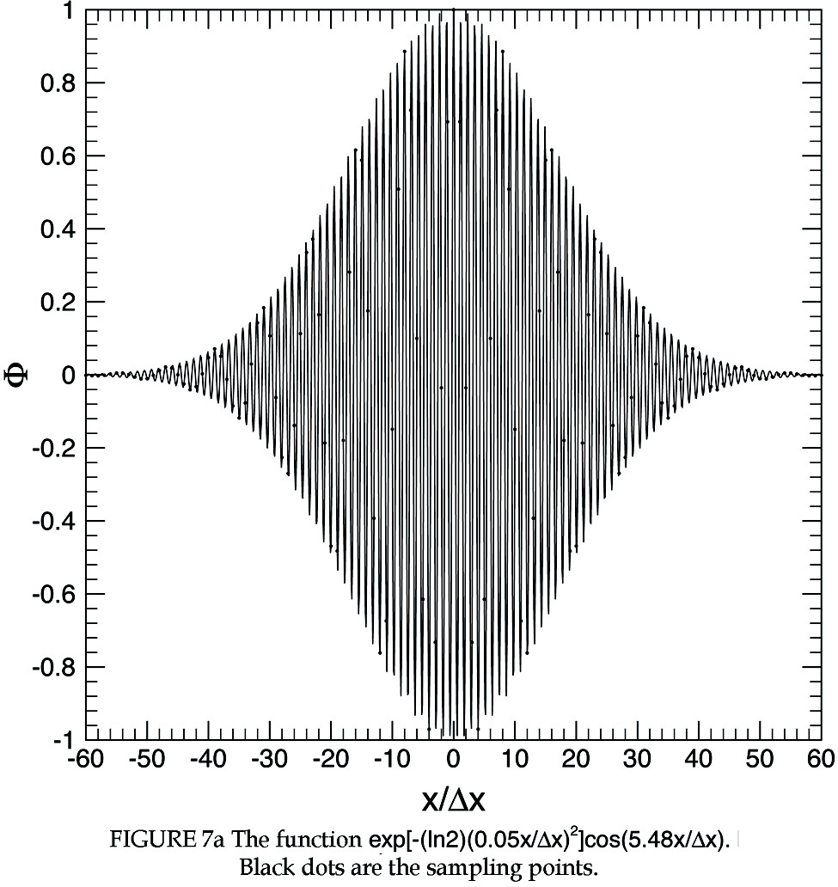

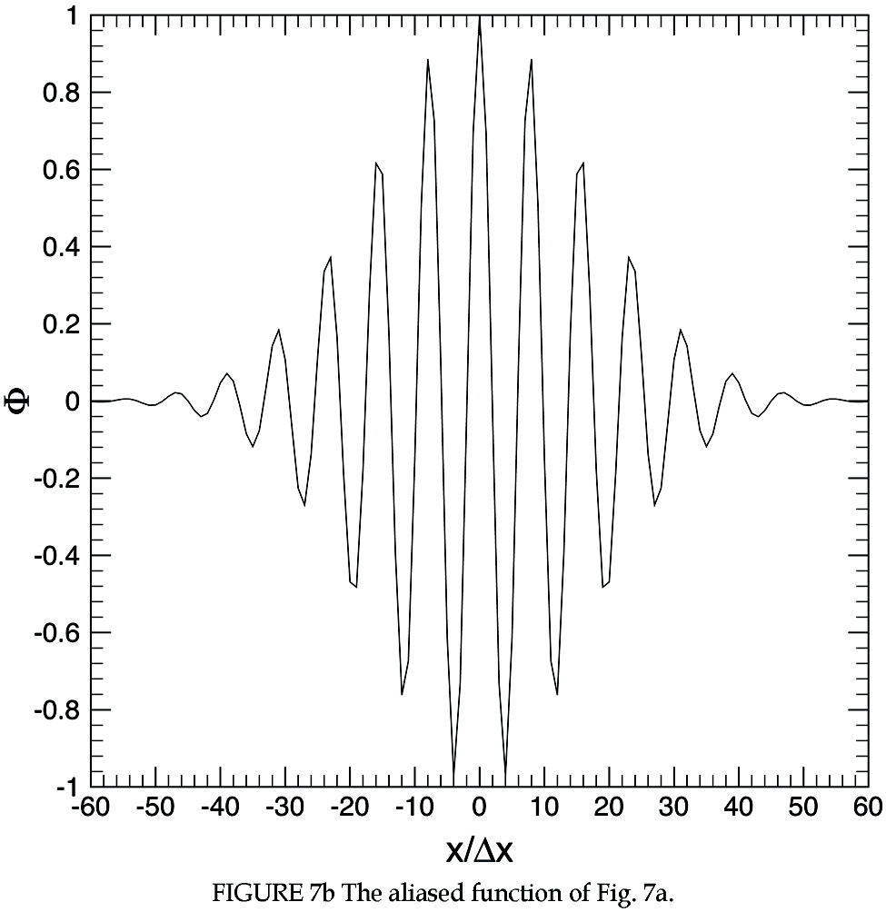

We will assume that $α_{0}Dx>p$ but less than $2p$. Since $α_{0}Dx$ is larger than $p$, we may write
$α_{0}Dx=p+d$. (41)
But
$e^{{iα}_{0}Dxl}=e^{i\left[2p+\left(d−p\right)\right]l}=e^{i\left(d−p\right)l}=e^{i\left(\frac{d−p}{Dx}\right)x}=e^{i\left(α_{0}−\frac{2p}{Dx}\right)x}$

Therefore, the initial condition is the same as
$t=0 F\left(x\right)=e^{−\left(\text{ln}2\right){\left(\frac{x}{b}\right)}^{2}+i\left(α_{0}−\frac{2p}{Dx}\right)x}$ (42)
for the computation. In other words, the effective wave number is,
$α=α_{0}−\frac{2p}{Dx}$ (43)
or
$αDx=α_{0}Dx−2p$. (44)
Hence, although $α_{0}Dx$ is larger than $p$, it is aliased back into the fundamental range by a shift of $2p$.
As an example, consider the function
$F\left(x\right)=e^{−\left(\text{ln}2\right){\left(\frac{0\text{.}\text{05}x}{Dx}\right)}^{2}}\text{cos}\left(\frac{5\text{.}\text{48}x}{Dx}\right)$. (45)
The wave number of this function concentrates around $α_{0}Dx=5\text{.}\text{48}$. This is outside the fundamental range. For computation on the mesh, the effective wave number, according to (44), is $αDx\text{=-}0\text{.}\text{803}$. Figure 7a shows the original function (45), with wave number concentrates around $α_{0}Dx=5\text{.}\text{48}$. The black dots in the figure are sampling points. From the finite difference computation point of view, only the sampling points matter. Figure 7b shows the function representing the sampling points. This function is the same as
$F\left(x\right)=e^{−\left(\text{ln}2\right){\left(\frac{0\text{.}\text{05}Dx}{x}\right)}^{2}}\text{cos}\left(\frac{0\text{.}\text{803}x}{Dx}\right)$.
This function has a low wave number.

3. COMPUTATIONAL ISSUES/CHALLENGES RESOLVED

Many of the major computational issues and challenges to CAA listed in the introduction of this paper have now been resolved or partly resolved. Here, a brief overview of the methods, analysis and new ideas that are introduced to meet the challenges is provided. For specific details, the readers are encouraged to read the original source msterials.
At the outset, it was clear to investigators that a fundamental need in CAA was to develop algorithms that could resolve high frequency short waves with the minimum number of mesh points per wavelength. Standard CFD second-order schemes often require 18 to 25 mesh points per wavelength to ensure adequate accuracy. This large number of mesh points is, of course, not acceptable if the method is to be adopted for practical computation. It was soon recognized that a solution to the problem was to use large stencil high resolution CAA schemes. Presently, reasonable size high resolution algorithms can resolve waves using 6 to 8 mesh points per wavelength. Very large stencil methods such as the 15-point stencil DRP scheme can resolve waves with as few as 4 mesh points per wavelength. The compact scheme initiated by Lele (1992) and the DRP scheme of Tam & Webb (1993) have since gained wide acceptance in CAA applications. However, there are fundamental differences between the two methods. The compact scheme is a global scheme relating every mesh point on the stencil line. The DRP scheme is basically a local scheme with its influence and dependence defined by the stencil size. Because of the global versus local nature of the schemes, the treatment of the stencils at computation boundaries are quite different. The boundary stencils used often have significant influence on the quality of the computed solution. For this reason, they should be designed properly.
One of the most significant differences between traditional CFD and CAA methodology is the method of error analysis. In CFD, the standard way to assess the quality of a scheme is by the order of Taylor series truncation. It is generally assumed that a fourth-order scheme is better than a second-order scheme, that, in turn, is better than a first order scheme. But all these are qualitative not quantitative. There is no way to find out by order of magnitude analysis how many mesh points per wavelength are needed to achieve, say, a half-percent accuracy in a computation. Traditional numerical analysis also does not provide a way to quantify wave propagation errors. Dispersion and dissipation errors are often erroneously linked to the phase velocity and amplification factor.
The development of wave number analysis, through the use of Fourier-Laplace transforms, has provided a firm mathematical foundation for error analysis in CAA. Wave number analysis shows that it is not the order of a scheme that is important. It is the resolved bandwidth of a scheme in wave number space that is important. As far as numerical wave propagation error is concerned, wave number analysis shows that phase velocity is totally irrelevant. Rather, it is the group velocity and the dependence of $d{\bar{α}}/{dα}$ and $d{\bar{w}}/{dα}$ of the scheme on wave number that are important. In wave propagation, space and time play an important partnership role. The relationship is all encoded in the dispersion function. Thus a dispersion-relation-preserving scheme would automatically guarantee not only a numerically accurate solution but also the number of wave modes (acoustic, vorticity and entropy) and their characteristics supported by the computation scheme are identical to those of the original partial differential equations. Wave number analysis has opened a way for the development of many optimized schemes (e.g., Tam & Webb, 1993; Lockard et al., 1995; Kim & Lee, 1996; Zhuang & Chen, 1998, 2002; Li, 1997; Orlin et al,1997; Gaitande & Shang, 1997; Lee & Soo, 2002). It provides an understanding of the existence and characteristics of spurious short waves. Such knowledge allows the design of very effective artificial selective damping stencils (Tam et al., 1993) and filters (Visbal & Gaitande, 2001). Wave number analysis, together with the dispersion relation of the discretized equations, offer a simple quantitative method for analyzing numerical stability of CAA algorithms (see Tam & Webb, 1993). Such an analysis is crucial to the selection of the size of time marching step.
The fact that acoustic waves have small amplitude compared to that of the mean flow have raised a good deal of initial apprehension as to whether the inherent noise level of a numerical scheme used to compute the mean flow would overwhelm the actual radiated sound. Such apprehension is well founded for experience has indicated that some CFD schemes do have a high intrinsic noise level. The development of new high resolution CAA methods have proven that it is, indeed, possible to capture sound waves of minute amplitude with good accuracy. In a definitive demonstration of such possibility Tam & Dong (1996) considered the computation of sound radiation from an oscillatory source in a non-uniform mean flow using the DRP scheme. The computed mean flow solution was found to differ from the exact solution with a maximum error of 2.5%. The fluctuating acoustic velocity generated by the oscillatory source was set equal to about ${\text{10}}^{−9}$ of that of the mean flow. In other words, the mean flow computation error is many orders of magnitude larger than the sound intensity. Despite the low level of sound, the DRP scheme was able to capture the acoustic radiation. Tam & Dong found good agreement between the computed sound intensity and the exact analytical solution.
The importance of high quality numerical boundary conditions for CAA can never be overemphasized. There is no exaggeration in saying that development of high quality numerical boundary condition is as important as the development of a high quality time marching scheme. This is why in this special issue of IJCFD, three articles are devoted to numerical boundary conditions. The article by Hixon (2004) reviews the status of radiation and wall boundary conditions. The article by Hu (2004) discusses absorbing boundary conditions. The article by Fung & Ju (2004) is devoted to a review of boundary conditions for sound absorbing surfaces or acoustic liners. The inside of all current commercial jet engines are fitted with acoustic liners. Historically, impedance boundary conditions were formulated in the frequency domain. Recent effort concentrates on converting frequency domain boundary condition to stable time domain boundary conditions to allow the effect of acoustic liners to be included in a time domain calculation.
Aeroacoustic problems generally involved disparate length and time scales. One reason that they are multi-scales problems is that the length scale of the noise source is very different from the acoustic wavelength. Another reason is that the dominant physics of the problem changes in different parts of the computation domain. Thus the local length and time scales could be vastly different. To deal with large disparate length and time scales computationally, Tam & Kurbatskii (2003) recently proposed a multi-size-mesh multi-time-step DRP scheme. The strategy of the scheme is to divide the computation domain into many subdomains. A uniform size mesh is used in each subdomain. The mesh size and time step change by a factor of two between neighboring subdomains. The use of multi-domain is not new. What is new in their scheme is that the time step used in neighboring subdomains also change by a factor of two. Because of very large disparate time steps are used, most of the computations are concentrated in the very fine mesh region. In most CFD and CAA computation schemes, the time step is constrained by the stability requirement of the smallest size mesh. As a result, a lot of unnecessary computations are done over the coarse mesh region. By comparison, the multi-size-mesh multi-time-step DRP scheme is, therefore, computationally very efficient and economical.

4. CAA APPLICATIONS

In this special issue of IJCFD, four application areas of CAA are highlighted each by a special article; jet noise (Bailly & Bogey), fan noise (Envia, Wilson & Huff), airframe noise (Singer & Guo) and cavity noise (Takeda & Shieh). Here interesting and important CAA applications that are not covered in these articles are briefly reviewed.

4.1. Screech Tones

Screech tones are discrete frequency sound emitted by imperfectly expanded supersonic jets (see Tam, 1991, 1995b). It is known that these tones are generated by self-excited feedback loops driven by the instability waves of the jet flow. Sound is generated at about the 4th and 5th shock cells by the interaction of instability waves, which have grown to a large amplitude at these locations, and the shock cells inside the jet plume. Tam (1995b) pointed out that because the feedback loop was highly nonlinear, there was no analytical or even semi-empirical formula for predicting the tone intensity. Thus screech tone intensity prediction had been an open problem in aeroacoustics. It was, for a long time, also an inviting challenge to CAA.
Shen & Tam (1998, 2000, 2002), Manning & Lele (1998, 2000), Loh et al. (2001) independently performed numerical simulations of the jet screech phenomenon. The latest work of Shen & Tam appears to be most complete. It reproduces all the observed salient features of screech tones, including the existence of four modes, namely, the $A_{1}$, $A_{2}$ (symmetric modes) and $B$, $C$ (flapping modes) mode, the staging of modes, the effect of jet temperature and nozzle lip thickness. The measured screech frequencies as a function of jet Mach number for both cold and heated jets from the numerical simulations of Shen & Tam are found to be in excellent agreement with the experimental measurements of Ponton & Seiner (1992), Massey (1997) and Massey & Ahuja (1997). The mean velocity profile and shock cell structure are also found to agree well with the measurements of Lau (1981) and Norum & Brown (1993). Most importantly, the simulated tone intensities are in favorable agreement with the data of Ponton & Seiner (1992). It turns out the good agreement is not confined to the dominant tone. Even the sound-pressure-level (SPL) of the secondary tones, which is about 10 dB lower, is also in good agreement.
Several aspects of the computation algorithm, numerical boundary conditions and turbulence modeling used in the works of Shen & Tam are quite new and worthwhile to point out. As the shock cells in the jet plume are crucial to screech tone generation, the computation scheme must be capable of capturing shock and sound waves simultaneously. Computationally, these are not compatible goals. Traditional shock capturing scheme would tend to eliminate the oscillatory sound waves. For shock capturing purposes, Shen & Tam used the method of Tam & Shen (1993) developed earlier. This method relies on the addition of artificial selective damping to eliminate spurious oscillations that are often found around a computed shock but would not damp out sound waves.

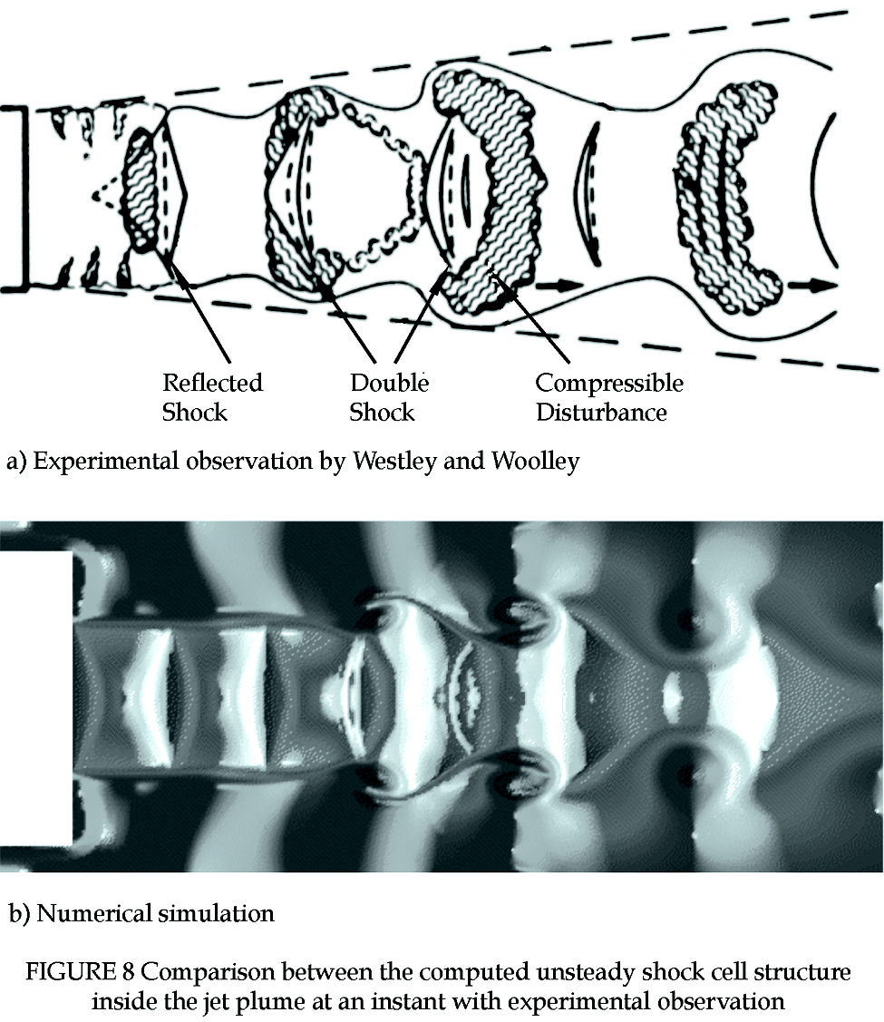

Figure 8b shows the computed density distribution in a plane passing through the centerline of a Mach 1.2 jet. The jet is in an axisymmetric $A_{2}$ screech mode. The figure displays a snapshot of the screech cycle. The shear layer surrounding the jet is highly unstable. The instability wave rolls up to form a row of quasi-periodic toroidal vortices. By viewing a video of the numerical simulation, it becomes clear that the shock cell structure is very unsteady. This is caused by the passage of the large toroidal vortices through the outer port of the shock cells. Figure 8a is a sketch of the visual spark schliren observation of Westley & Woolley (1968). Spark schliren uses light passing through the entire cross-section of the jet. Thus, in Westly & Woolley’s observations, the large toroidal vortices have the shape of the compressible disturbances sketched in Fig. 8a. By comparing the flow and shock structure displayed in these two figures, it is easy to see that the numerical simulation shows remarkable resemblance to the experimental observation even though the unsteady shock cell structure is fairly complex.
In the mixing layer of a jet, there are fine scale turbulence as well as large turbulence structures/instability waves. Because of the large disparity in length scale between the two and that the role of the fine scale turbulence is essentially to broaden the mixing layer and has little to do with screech tone generation, Shen & Tam decided that it was not necessary to resolve or compute the fine scale turbulence in details. They chose a $k−e$ turbulence model to imitate the effect of fine scale turbulence on the jet flow to ensure that the jet had proper spreading rate. This is important, for the spreading rate of a jet regulates the growth of the instability wave that affects the screech tone intensity. Effectively, the numerical simulations involve the solution of the unsteady Reynolds Averaged Navier-Stokes equations (URANS).

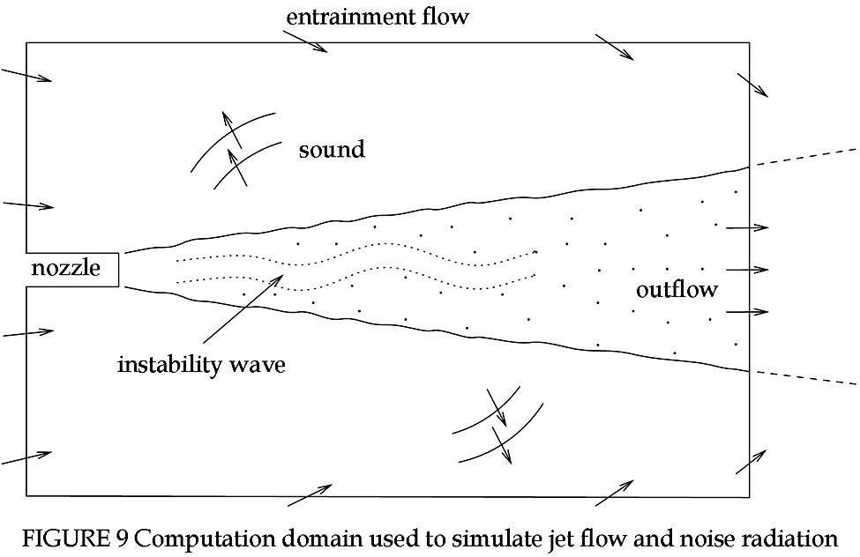

High-speed jets are known to entrain a large quantity of ambient air (see Fig. 9). In numerical simulation, a finite computation domain is used. How to simulate entrainment flow that starts outside the finite computation domain presents a serious challenge to the proper formulation of numerical boundary conditions. In screeching jet simulations, the boundary conditions are required to impose the correct ambient static pressure (important for the proper expansion of the supersonic jet and the development of the shock cells). In addition they are to be transparent to outgoing acoustic waves of the screech cycle and, at the same time, produce the entrainment flow. If no specially designed entrainment flow boundary conditions are used, computed results would show the existence of a large recirculation region immediately outside the jet. Such a recirculation region does not exist in free jet experiments. The entrainment flow boundary conditions adopted by Shen & Tam were discussed in details in a review article (Tam, 1998). Readers who are interested may consult the original article.

4.2. Transonic Resonance

It is known that at pressure ratio below the design value, convergent-divergent nozzles often undergo a flow resonance accompanied by the emission of strong tones. Recent experimental observations by Zaman et al. (2002) confirmed that the tones are related to a feedback inside the nozzle. Crucial to the existence of these tones is the occurrence of unsteady flow separation downstream of the nozzle throat. The flow separation causes highly unsteady oscillations of the shock sitting inside the overexpanded C-D nozzle. The precise mechanism responsible for transonic resonance is not fully known. This motivated Loh and Zaman (2002) to perform numerical simulation of the phenomenon to shed light on the feedback process.
Loh & Zaman used the CE/SE method (chang, 1995; Chang et al., 1999). The CE/SE method is based on an integral formulation in which there is coupling between space and time discretization. In the hands of experienced experts, the method has produced impressive results. Detailed analysis of the propagation characteristics of the scheme, however, has yet to be done. This is, perhaps, due to the complexity of the scheme. One interesting aspect of the Loh & Zaman simulations is that in spite of the recognition that there is unsteady boundary layer separation and that the separated shear layer has large velocity gradient, indicating the importance of viscous effect, only the Euler equations are solved. All viscous effects including the satisfaction of no-slip boundary condition on the nozzle wall are made possible by the intrinsic numerical viscosity of the scheme. However, the simplicity of the physical model notwithstanding, the simulations are quite successful in the sense that they reproduce the experimentally observed transonic resonance. The calculated tone frequencies as a function of jet Mach number are in good agreement with experimental measurements. Furthermore, as is often the case with feedback phenomenon, a jump in the tone frequency was observed within the Mach number range of the experimental measurements of Zaman et al. This frequency jump is reproduced by the simulation data. This is definitely not a simple coincidence.
In the literature, there are examples in which numerical viscosity was used successfully in lieu of real viscosity in flow and acoustic computations. The work of Loh & Zaman unquestionably falls into this category. Admittedly, this may be regarded by some as a crude approximation of the real physical processes. On the other hand, one should not dismiss this type of approach outright. What is needed is a better understanding of the role numerical viscosity plays in large scale simulations using high resolution computation schemes.

4.3. Acoustic Liner Simulation

Presently, the most effective way to reduce fan noise, both tones and broadband sound, from jet engines is to install acoustic liners on the inside of the engine wherever space permits. A jet engine acoustic liner usually consists of a face sheet full of small holes (see Motsinger & Kraft (1991)). The holes are usually arranged in a regular pattern. Underneath the face sheet are cavities, sometimes called resonators. When sound waves impinge on the surface of a liner, they cause the pressure to rise and fall. During the high pressure half of a cycle, fluid is forced into the cavities through the holes. During the low pressure half of a cycle, fluid flows back out from the cavities. It has been known for a long time that it is the viscous damping of the oscillating flow in and out of the holes connecting the outside to the cavities that is responsible for the dissipation of the incident sound. However, the holes are very small, typically 1 mm or less in diameter. Because of the smallness of the holes, there has not been experimental observation of the actual flow and acoustic fields around the holes.
In the past, there were suggestions by some investigators that wall friction was responsible for acoustic dissipation. Based on experiments carried out using larger size holes (larger Reynolds number), others have suggested that the oscillatory flow through the holes led to the formation of oscillatory turbulent jets. Acoustic dissipation is the result of the conversion of acoustic energy to fluid turbulence, which is subsequently dissipated by molecular viscosity. As far as numerical simulation is concerned, the small size of the holes is no hindrance. This motivated Tam & Kurbatskii (2000a) and Tam et al. (2001a, 2003a) to perform direct numerical simulation of a slit resonator (a single slit and a single cavity) under acoustic excitation to investigate the mechanisms by which a perforated acoustic liner dissipate sound. To ensure that the numerical results were valid, physical experiments were performed in parallel. In these experiments gross quantities such as impedance and reflection coefficients, but not detailed flow field, were measured. Tam & Kurbatskii (2000a) found from their numerical simulations that at low incident sound pressure level, a jet-like oscillatory shear layer was formed near each side wall of the slit. The viscous dissipation associated with these jet-like shear layers was primarily responsible for acoustic energy dissipation. At high incident sound pressure level, they observed vortex shedding at the corners of the slit opening connecting the resonator to the outside (see Fig. 10a). There was a large increase in dissipation whenever there was vortex shedding. The dominant dissipation mechanism was the conversion of acoustic energy into the rotational kinetic energy of the shed vortices. These vortices were subsequently dissipated into heat by molecular viscosity. The computed reflection coefficient and impedance over a wide range of frequencies, slit widths and slit geometry (see Fig. 10b for beveled slit) were found to be in excellent agreement with the companion experimental measurements (Tam et al, 2003). The good agreement offered confidence in the accuracy of the flow and acoustic field including vortex shedding provided by the numerical simulation but not directly measured or observed in the experiments.
Numerical simulation of acoustic liners had been attempted by other investigators previously. . However, these investigators failed to recognize the multi-scales nature of the problem. They used a uniform size mesh in their computation. The mesh size was adequate to resolve the acoustic waves but too coarse to capture the viscous layers near the slit opening. As a result, their simulation did not produce vortex shedding at high sound pressure level nor strong oscillatory jet flows adjacent to the walls of the slit at low incident sound pressure level. There are two dominant effects in this problem. Near the opening of the slit or hole, viscous forces are important. Away from the opening, compressibility effect is most important. At the walls of the opening, the oscillatory fluid motion induces the formation of a viscous Stokes layer (see White, 1991, Chapter 3). The wavelength, $λ$, of an oscillatory Stokes layer is

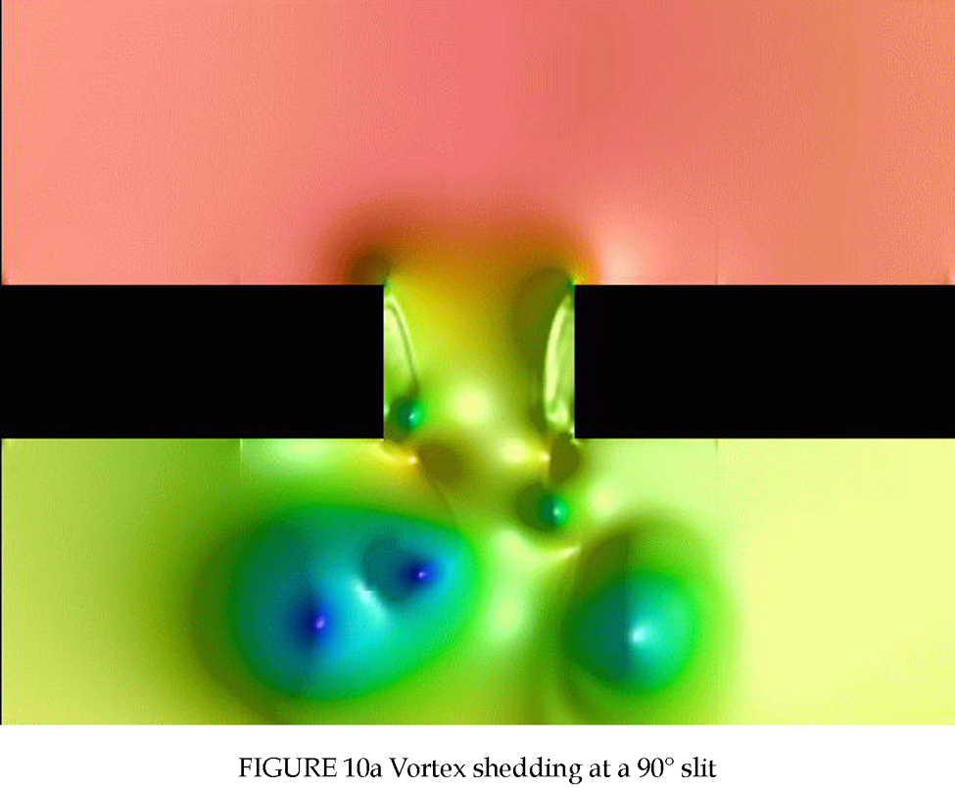

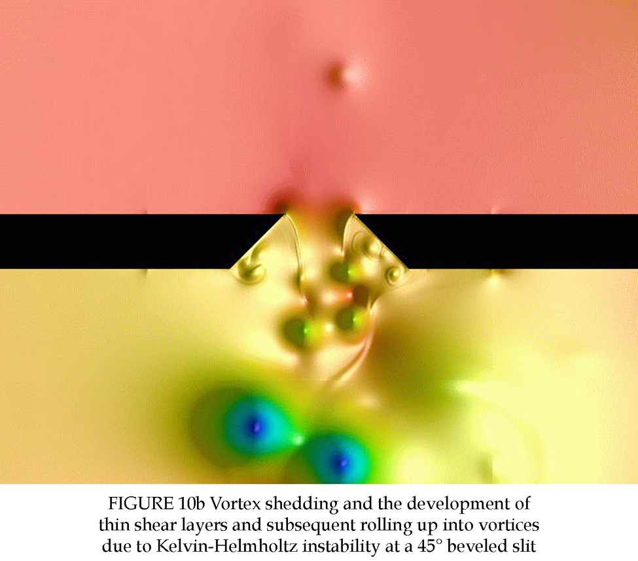

$λ=2{\left(\frac{\text{pν}}{f}\right)}^{\frac{1}{2}}$ (46)

where $ν$ is the kinematic viscosity and $f$ is the frequency. Suppose the 7-point stencil DRP scheme is used for computation. Since this scheme can resolve waves using 7 or 8 mesh points per wavelength, the mesh size required at the slit is $(Dx)_{\text{Stokes}}=λ/8=0\text{.}8(ν/{pf})^{1/2}$. Outside the slit opening region, the fluid motion is dominated by compressibility effect. The acoustic wavelength is ${a_{0}}/f$ where $a_{0}$ is the speed of sound. To meet resolution requirement, the mesh spacing must, therefore, be equal to or less than $(Dx)_{\text{acoustic}}={a_{0}}/(8f)$. The ratio of mesh size is,
$\frac{{\left(Dx\right)}_{\text{acoustic}}}{{\left(Dx\right)}_{\text{Stokes}}}=\frac{0\text{.}\text{277}a_{0}}{{\left(νf\right)}^{\frac{1}{2}}}$ (47)
under standard conditions, this ratio is equal to 640 for 3 kHz sound. It would make no sense to use a uniform size mesh for direct numerical simulation. In the work of Tam et al.(2003), the multi-size-mesh multi-time-step DRP scheme of Tam & Kurbatskii (2003) was used. The computation domain was partitioned into 8 subdomains inside and outside the resonator. Thus the largest size mesh was $2^{7}$ times larger than the smallest size mesh. This also applied to the time steps. Effectively, more than half of the computation was performed in the three subdomains with the finest meshes.
Acoustic liners are designed not only to damp out tones with discrete frequencies. They must also be effective in absorbing broadband sound waves. How to simulate broadband incident sound waves with a given noise power spectrum was a problem considered by Tam et al. (2003). They developed a discrete frequency model that seemed to work reasonably well. The simulation of broadband incident sound is an entirely new area in CAA. One problem that CAA must face in dealing with broadband noise is the length of computed data. This is usually short for most large scale computing because of the long wall clock time needed to run the code (weeks, not days). Sometimes it is also because the available computer resources are limited. The short data length is a critical problem in processing statistics of the simulated data. A short discussion and an analysis of this problem is provided in Tam et al. (2003).

5. OUTSTANDING CHALLENGES

As CAA matures and the scope of applications broadens, new computational challenges emerge even as some of the original challenges are resolved. In this section, an attempt is made to identify some of the outstanding challenges currently confronting CAA.

5.1. Size of Computation Domain

Many CAA problems are exterior open domain problems. For this class of problems, it is clear that the computation domain should be large enough to contain all the sources of noise. However, there seems to be no guidance on how large the computation domain ought to be. To fix ideas, let us consider the automobile door cavity tone problem of the 3rd CAA Workshop on Benchmark Problems. A cross-section of the cavity is shown in Fig. 11. In this problem, the shear layer spanning the mouth of the cavity is unstable. This leads to significant oscillation of the shear layer. At the trailing edge of the cavity, the interaction of the oscillatory shear layer and the sharp corner results in the generation of tones. Now, to simulate this problem, the computation domain is taken to be as shown in Fig. 11 except that one has to decide how far to place the boundaries from the trailing edge of the cavity.

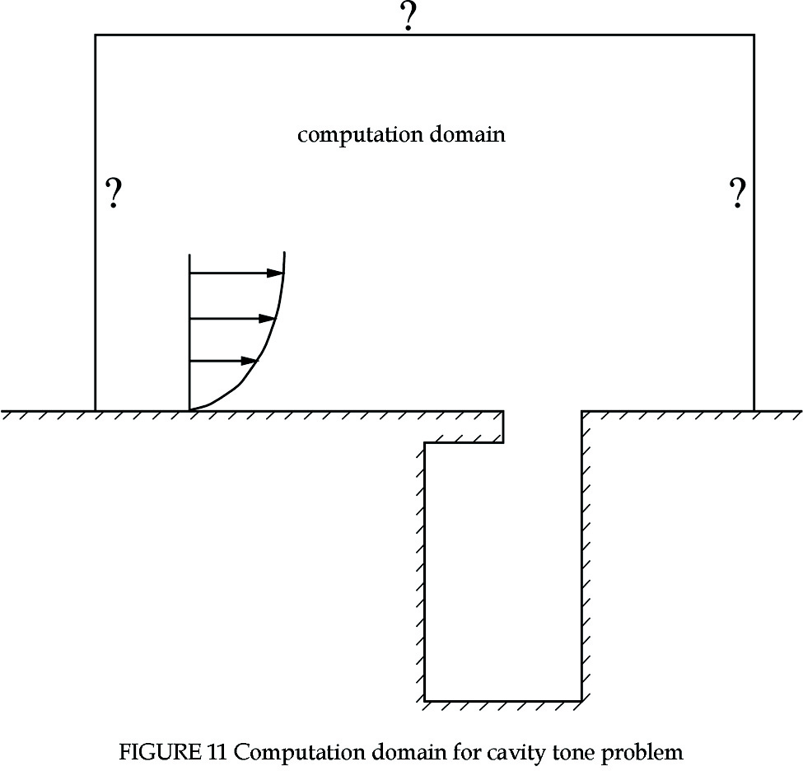

In their paper on the cavity tone problem, Kurbatskii & Tam (2000) did investigate numerically the effect of the size of computation domain on the cavity tone phenomenon. They concentrated on the case of outside flow velocity at 50.9 m/s and an incoming boundary layer (laminar) of 2 mm thick. For these conditions, the tone frequency is around 2 kHz. Kurbatskii & Tam performed three computations using three different size computation domains. The smallest size domain was $0\text{.}3λ$ (horizontal) by $0\text{.}\text{23}λ$ (vertical) where $λ$ is the acoustic wavelength. The moderate size domain was $1\text{.}8λ$ by $0\text{.}9λ$. The largest domain was $2\text{.}8λ$ by $1\text{.}4λ$. The computed results indicated that the two large size domains gave almost identical results with a tone at 1992 Hz and a sound pressure level (SPL) of 125.6 dB measured at the center of the upstream wall inside the cavity. The smallest size domain gave quite a different result. The tone frequency was higher at 2193 Hz and the SPL increased to 131.8 dB. They examined the fluctuations inside the smallest computation domain and found normal mode type oscillations over the entire domain. In designing their computation algorithm, Kurbatskii & Tam used asymptotic radiation and outflow boundary conditions. They suspected that unless the boundary conditions were imposed in the far field, partial reflection could occur leading to normal mode type oscillations. They recommended that as a rule of thumb if asymptotic radiation or outflow boundary conditions were used, the computation domain boundaries should be placed at least one wavelength away from the sources.
What is lacking is a more definitive theoretical criterion for determining the size of computation domain. Such a criterion would naturally depend on the type of boundary conditions used as well as on the time marching computation scheme. The simple empirical rule of one wavelength is not a problem to implement if the tone frequency is high. For low frequency oscillations, one wavelength could be extremely long. This may not be computationally feasible. A fundamental investigation of this problem would be most desirable and helpful to CAA.

5.2. Outflow Boundary Conditions

In many CAA simulations, the boundary of the computation domain cuts across an outflow. A typical example is the case of simulating jet noise generation as shown in Fig. 9. Since numerical boundary conditions imposed at the outflow boundary must reproduce all the external effects on the flow field inside the computation domain, the outflow boundary is usually placed sufficiently far downstream of the nozzle exit to avoid significant upstream influence of the jet flow left outside. In the jet noise problem, as in many other problems, the mean flow is not known a priori. The computation is to capture the mean flow as well as the radiated sound. In such a situation, it seems reasonable that the outflow boundary conditions should be designed so as to be not only transparent to outgoing acoustic and other disturbances (vorticity and entropy waves) but also capable of recovering the mean flow. Presently, many CAA boundary conditions are formulated under the assumption that the mean flow is known. Their main concern is to avoid any reflection of the outgoing disturbances.
Dong (1997) recognized the need for CAA outflow boundary conditions to be capable of capturing the mean flow correctly. He proposed a set of asymptotic outflow boundary conditions based on sink/source flows. In two dimensions, they are,
$\begin{aligned}\frac{1}{a_{¥}}\frac{¶p}{¶t}+\frac{¶p}{¶r}+\frac{2}{r}\left(p−p_{¥}\right)=0 \\ \frac{1}{a_{¥}}\frac{¶u}{¶t}+\frac{¶u}{¶r}+\frac{u}{r}=0 \\ \frac{1}{a_{¥}}\frac{¶v}{¶t}+\frac{¶v}{¶r}+\frac{v}{r}=0 \\ \frac{1}{a_{¥}}\frac{\text{¶ρ}}{¶t}+\frac{\text{¶ρ}}{¶r}+\frac{2}{r}\left(ρ−ρ_{¥}\right)=0\end{aligned}$ (48)
where $r$ is the radial distance in polar coordinates. $p_{¥}$, $ρ_{¥}$ and $a_{¥}$ are the ambient pressure, density and sound speed, respectively. Dong derived this set of outflow boundary conditions by noting that the asymptotic solution of a time independent localized source in two dimensions, denoted by an overbar, is
$\begin{aligned}\bar{ρ}=ρ_{¥}−\frac{Q^{2}}{8p^{2}{gp}_{¥}r^{2}}+O\left(\frac{1}{r^{4}}\right) \\ {\bar{v}}_{r}=\frac{Q}{2{\text{pρ}}_{¥}r}+O\left(\frac{1}{r^{3}}\right) \\ \bar{p}=p_{¥}−\frac{Q^{2}}{8p^{2}ρ_{¥}r^{2}}+O\left(\frac{1}{r^{4}}\right)\end{aligned}$ (49)
where $Q$ is the source strength, $g$ is the ratio of specific heats and $v_{r}$ is the radial velocity component. It is easy to verify that (49) is a solution of (48) to order $O(r^{−4})$. On the other hand, the asymptotic solution of outgoing acoustic waves in two dimensions as given by Tam & Webb (1993) is,
$\left[\begin{matrix}ρ \\ u \\ v \\ p\end{matrix}\right]=\frac{F\left(\frac{r}{a_{¥}}−t,q\right)}{r^{\frac{1}{2}}}\left[\begin{matrix}\frac{1}{a_{¥}^{2}} \\ \frac{\hat{u}\left(q\right)}{ρ_{¥}a_{¥}} \\ \frac{\hat{v}\left(q\right)}{ρ_{¥}a_{¥}} \\ 1\end{matrix}\right]+O\left(r^{−\frac{3}{2}}\right)$. (50)
By substitution of (50) into (48), it is easy to find that (48) is satisfied to order $O(r^{{−3}/2})$. Dong pointed out (48) was very similar to the asymptotic boundary conditions of Tam & Dong (1996). The main difference was in the numerical coefficients of the $1/r$ terms. He noticed that the asymptotic solution of the mean flow of a localized source and that of outgoing acoustic waves have different dependence on $r$. (48), as an outflow boundary condition, was a good compromise.
Jet flows are not source flows. Boundary layer argument as well as experimental measurements suggest that the static pressure across a jet far downstream is practically constant and is equal to the ambient pressure. In this case, $\bar{p}=p_{¥}$ is a good mean flow pressure boundary condition. In the work of Shen & Tam (1998), the following boundary conditions were used at the outflow of a jet. Written in cylindrical coordinates $(r,f,x)$, they are,

$\begin{aligned}\frac{\text{¶ρ}}{¶t}+u\frac{\text{¶ρ}}{¶x}+v\frac{\text{¶ρ}}{¶r}+\frac{w}{r}\frac{\text{¶ρ}}{\text{¶f}} \\ =\frac{1}{a^{2}}\left(\frac{¶p}{¶t}+u\frac{¶p}{¶x}+v\frac{¶p}{¶r}+\frac{w}{r}\frac{¶p}{\text{¶f}}\right)\end{aligned}$ (51a)
$\frac{¶u}{¶t}+u\frac{¶u}{¶x}+v\frac{¶u}{¶r}+\frac{w}{r}\frac{¶u}{\text{¶f}}\text{=-}\frac{1}{ρ}\frac{¶p}{¶x}$ (51b)
$\frac{¶v}{¶t}+u\frac{¶v}{¶x}+v\frac{¶v}{¶r}+\frac{w}{r}\frac{¶v}{\text{¶f}}−\frac{w^{2}}{r}\text{=-}\frac{1}{ρ}\frac{¶p}{¶r}$ (51c)
$\frac{¶w}{¶t}+u\frac{¶w}{¶x}+v\frac{¶w}{¶r}+\frac{w}{r}\frac{¶w}{\text{¶f}}+\frac{\text{vw}}{r}\text{=-}\frac{1}{ρ}\frac{1}{r}\frac{¶w}{\text{¶f}}$ (51d)
$\frac{1}{V\left(q\right)}\frac{¶p}{¶t}+\frac{¶p}{¶R}+\frac{p−p_{¥}}{R}=0$ (51e)

where $V(q)=u\text{cos}q+a(1−M^{2}{\text{sin}}^{2}q)^{1/2}$ and $M=u/a$. $a$ is the speed of sound. $(R,q,f)$ are the spherical polar coordinates with the polar axis coinciding with the centerline of the jet. (51) is derived from the outflow boundary conditions of Tam & Webb (1993) and Tam & Dong (1996) by nonlinearizing the convective terms. For the mean flow, $p=p_{¥}$ is a solution of (51e). (51b), (51c) and (51d) are identical to the momentum equations. So the velocity field should be given correctly by them. For time independent solution, (51a) reduces to

$u\frac{\text{¶ρ}}{¶x}+v\frac{\text{¶ρ}}{¶r}+\frac{w}{r}\frac{\text{¶ρ}}{\text{¶f}}=0$. (52)

(52) is the same as $ρ=$constant along a streamline. This should be reasonably good for jet flow far downstream where there is no intense mixing. Thus (51), although originally designed primary for outgoing disturbances, is also capable of capturing the mean flow of a jet accurately.
Now (48) and (51) are very different. Each aims specifically for a special class of outflow. In general, one does not know whether the mean flow is source-like or jet-like. What is needed is a set of outflow boundary conditions that is applicable to more general outflow.
5.3. Complex Geometry

In many aeroacoustics problems such as those in fan and airframe noise, the computation has to deal with fairly complicated geometry. How to integrate complex geometry into high resolution schemes is, perhaps, one of the most pressing challenges to CAA at this time. In CFD, there are, in general, two ways to treat complex geometry. The most popular method is unstructured grids. Another method is overset grids. Currently, unstructured grids are most often used in conjunction with finite volume schemes. Finite volume schemes are low order schemes (first or second order). These first or second order schemes are too dispersive and too dissipative. They are not suitable for wave propagation computations. Furthermore, for problems with boundary layer type flows, a structured body-fitted grid would be more accurate and thus preferred.
There are now some successes in using overset grids for CAA. Early usage was carried out by Delfs (2001) and Yin & Delfs (2001). The work of Sherer and Visbal (2003) represents a significant advancement of the method. In the paper by Sherer & Visbal, acoustic scattering problems involving multiple bodies were solved by high-order overset grid method. For basic computation, they used a high-order compact scheme. For transferring information from one grid to another in the grid overlap region, interpolation was employed. Sherer & Visbal pointed out if second-order interpolation was used, it would result in a globally second-order accurate solution, even when high-order compact differencing and filtering were used in time marching computation. To remove this limitation, they formulated a high-order explicit Lagrangian method for interpolating data between grids.
The key to obtaining high-resolution solution by overset grids method obviously depends on the data transfer methodology. To ensure a globally high-resolution solution in wave number space, a high-resolution interpolation scheme should be used for data transfer. Recently, Tam & Hu (2003) developed a high-resolution interpolation scheme specifically for this purpose. This scheme is an extension of the work of Tam & Kurbatskii (2000b). The scheme obtains its interpolation coefficients by minimizing the interpolation error in multi-dimensional wave number space. By keeping the wave number resolution of the interpolation better or at least as good as the basic computation algorithm, a globally high-resolution solution is assured. Tam & Hu applied their overset grids method to both transient as well as time-periodic acoustic scattering problems. In addition, they also applied the method to a sliding grid problem. To compute fan wake and stator interaction noise, it is natural to use a fan blade fixed grid to compute the flow around the fan blades. This grid would be rotating with the fan. It is also natural to use a stator-blade fixed grid to calculate the flow around the stationary stator. The two blade fixed grids move relative to each other forming a sliding interface. Tam & Hu showed that such a sliding grid interface could be treated by overset grid method. They tested their method by considering the transmission of acoustic, vorticity and entropy waves across the sliding grid interface. They found excellent agreement between their computed results and exact solution.
Although progress has been made in resolving the problem of complex geometry, yet, this is such an important topic, new ideas and alternative methods are very much needed for CAA applications. The challenge is very much alive.

5.4. Turbulence Modeling

In aeroacoustics, turbulence is the principal source of broadband noise. Therefore, research and development of turbulence modeling and turbulence simulation are an integral part of CAA.
Because of the availability of larger and faster computers, turbulence, nowadays, becomes a favorite activity of large-scale computation. It is known that direct numerical simulation (DNS) of high Reynolds number turbulent flows requires exceedingly large number of mesh points and large CPU time. On account of such requirements, DNS is, presently, not considered feasible for solving practical CAA problems. Recently, attention has turned to large eddy simulation (LES). However, owing to the three-dimensional nature of turbulence, realistically, LES computation can be carried out only in relatively small computation domains in most instances. Simple estimates of mesh and computer time requirements would convince most that it would be sometime in the future, when much larger and faster computers become available, before LES would become a design tool in CAA.
The appeal of DNS and LES is that they can compute the entire or a large part of the turbulence spectrum. Because of the intense computation necessary, DNS and LES are sometimes regarded as a brute force approach. Nevertheless, DNS and LES in CAA should be encouraged. Since such a brute force approach is not feasible at this time a computationally less demanding approach based on somewhat different ideas is required if progress in predicting turbulence generated broadband noise is to be made.
For noise prediction, it is highly plausible that we do not need to know everything about turbulence or to be able to calculate the entire turbulence spectrum. How much do we really need to know about turbulence before we can calculate turbulence noise is an open question. It appears that if our primary concern is on the dominant part of the noise spectrum, it is very likely that we need only to resolve the most energetic part of the turbulence spectrum in a computation.
In CFD, calculating the mean velocity profile and other mean quantities of turbulent flows is important for engineering applications. For mean flow calculation, one may use a two-equation turbulence model (e.g., the $k−e$ or the $k−w$ model) or, if desired, a more advanced model. The question pertinent to us is whether models of a similar level of sophistication could be developed for noise calculation. Recent efforts of this kind have made significant progress in jet noise prediction. Tam & Auriault (1999) investigated how fine scale turbulence in a jet generates noise. They observed an analogy between pressure created by the random motion of blobs of fine scale turbulence and pressure created by random motion of gas molecules in gas kinetic theory. They proposed that since $q=(2/3)ρk$, where $k$ is the turbulence kinetic energy per unit mass, is the turbulence pressure according to the analogy, the dominant noise source of fine scale turbulence is the time rate of change of $q$ in the fluid frame of motion, that is ${\text{Dq}}/{\text{Dt}}$ where $D/{\text{Dt}}$ is the convective derivative.
Starting from such a proposition, they developed a fine scale turbulence noise theory for jets. The turbulence information needed by the theory including turbulence intensity, length and time scales, were provided by the turbulence model. The implementation of the theory such as calculating the mean flow profile, the adjoint Green’s function (to account for mean flow refraction effect) as well as the $k$, $e$ turbulence quantities was made possible by recently developed CAA methods. The noise spectra predicted by the Tam & Auriault theory were found to agree well with measured data over a wide range of jet Mach number (Mach 0.3 to 2.5) for axisymmetric jets. The same theory also predicted well for nonaxisymmetric jets (Tam & Pastouchenko, 2002) and jets in simulated forward flight (Tam et al, 2001b). Recently, the theory was found to be capable of predicting the noise source strength distribution along the axial direction of jets. The predicted distributions (Tam, Pastouchenko & Schlinker, 2003) both for selected Strouhal number and noise intensity (integrated over all frequencies) were in good agreement with the measurements of Laufer et al. (1976) and Schlinker (1975). Based on the success of the effort of Tam & Auriault it seems reasonable to suggest that, perhaps, CAA should focus on how turbulence generates noise rather than on turbulence as a subject by itself.
The Tam & Auriault theory is designed for predicting noise from fine scale turbulence in free shear flows. However, for broadband fan noise and airframe noise the interaction of turbulence and solid surfaces is an important source of noise. There is a critical need for such a theory. Any fresh idea that might shed light on how to begin developing this theory would be a significant contribution.

6. CONCLUDING REMARKS

In this paper, the needs and reasons for an independent development of CAA methods, rather than using available CFD methods, are presented. In CAA, numerical propagation errors are important. The two most important propagation errors are numerical dispersion and dissipation. The mathematical foundation for analyzing numerical dispersion and dissipation due to spatial and temporal discretization is provided and discussed in some details. Unlike traditional CFD, which assesses the quality of a computation algorithm according to the order of Taylor series truncation, CAA characterizes the quality by the width of the resolved band in wave number space. By means of wave number analysis, the group velocity and the spatial and temporal numerical damping rate of a CAA computation scheme can be calculated exactly. Progress in resolving some of the basic computation issues in CAA are reported. Outstanding issues and challenges are described. Some important CAA applications that are not within the scope of the application articles of this issue of IJCFD are briefly reviewed. In reviewing these applications, emphases are given to computational issues encountered in the computation/simulation. It is the intent of this article to provide a perspective of CAA for readers who might not be familiar with aeroacoustics. It is to be hoped that this article would stimulate interest in the subject, not only in methodology but also in applications.
When taken together, the 10 articles of this special issue of IJCFD should provide an overview of the current status of CAA as a sub-discipline. In a number of these papers, in addition to reviewing recent advances in the subject, suggestions are offered as to how CAA could assist future noise prediction and computation. These suggestions are valuable and serve as a guide to future CAA methodology development. The application articles in this special issue are all devoted to aircraft noise problems. But this is not the total scope of CAA applications. CAA methods have found applications in noise problems of other modes of transportation such as helicopters, automobiles, trucks and railroads. The methods have also been applied to many industrial flow noise problems.

Acknowledgements

This work was supported by NASA Grant NAG1-2145, NASA Contracts NAS1-02045, NAS3-02125 and the Aeroacoustics Research Consortium.

APPENDIX

The coefficients of the optimized 15-point stencil DRP scheme are $(h=1\text{.}8)$, $a_{−j}\text{=-}a_{j}$, $a_{0}=0\text{.}0$.
$$\begin{matrix}a_{1} & & −a_{−1} & & 9\text{.}\text{1942501110343045059277722885}D−1 \\ a_{2} & & −a_{−2} & & −3\text{.}\text{5582959926835268755667642401}D−1 \\ a_{3} & & −a_{−3} & & 1\text{.}\text{5251501608406492469104928679}D−1 \\ a_{4} & & −a_{−4} & & −5\text{.}\text{9463040829715772666828596899}D−2 \\ a_{5} & & −a_{−5} & & 1\text{.}\text{9010752709508298659849167988}D−2 \\ a_{6} & & −a_{−6} & & −4\text{.}\text{3808649297336481851137000907}D−3 \\ a_{7} & & −a_{−7} & & 5\text{.}\text{3896121868623384659692955878}D−4\end{matrix}$$

References

Ablowitz, M.J. and Fokas, A.S. (1997) Complex Variables: Introduction and Applications, Cambridge University Press.
Bailly, C. and Bogey, C. (2004) “Contributions of CAA to jet noise research and prediction”, International Journal of Computational Fluid Dynamics, to appear.
Chang, S.C. (1995) “The method of space-time conservation element and solution element — a new approach for solving the Navier-Stokes and Euler equations”, Journal of Computational Physics 119, 245–324.
Chang, S.C., Wang, X.Y. and Chow, C.Y. (1999) “The space-time conservation element and solution element method – a new high resolution and genuinely multidimensional paradigm for solving conservation laws”, Journal of Computational Physics 159, 89–136.
Delfs, J.W. (2001) “An overlapped grid technique for high resolution CAA schemes for complex geometries”, AIAA Paper 2001-2199.
Dong, T.Z. (1997) “On boundary conditions for acoustic computations in non-uniform mean flows”, Journal of Computational Acoustics 5, 297–315.
Envia, E., Wilson, A.G. and Huff, D.L. (2004) “Fan noise: A challenge to CAA”, International Journal of Computational Fluid Dynamics, to appear.
Fung, K.Y. and Ju, H. (2004) “Time domain impedance boundary conditions”, International Journal of Computational Fluid Dynamics, to appear.
Gaitonde, D. and Shang, J.S. (1997) “Optimized compact-difference-based finite-volume schemes for linear wave phenomena”, Journal of Computational Physics 138, 617–643.
Hixon, R. (2004) “Radiation and wall boundary conditions for computational aeroacoustics: A review”, International Journal of Computational Fluid Dynamics, to appear.
Hu, F.Q. (2004) “Absorbing boundary conditions”, International Journal of Computational Fluid Dynamics, to appear.
Hu, F.Q., Hussaini, M.Y. and Manthey, J.L. (1996) “Low-dissipation and low-dispersion Runge-Kutta schemes for computational acoustics”, Journal of Computational Physics 124, 177–191.
Kennedy, C.A. and Carpenter, M.H. (1994) “Several new numerical methods for compressible shear layer simulations”, Applied Numerical Mathematics 14, 397–433.
Kim, J.W. and Lee, D.J. (1996) “Optimized compact finite difference schemes with maximum resolution”, AIAA Journal 34, 887–893.
Kurbatskii, K.A. and Mankbadi, R.R. (2004) “Review of computational aeroacoustics (CAA) algorithms”, International Journal of Computational Fluid Dynamics, to appear.
Kurbatskii, K.A. and Tam, C.K.W. (2000) “Direct numerical simulation of automobile cavity tone”, Proceedings of the Third CAA Workshop on Benchmark Problems, NASA CP-2000-209790, 371–383.
Lau, J.C. (1981) “Effect of exit Mach number and temperatures on mean flow and turbulence characteristics in round jets”, Journal of Fluid Mechanics 105, 193–218.
Laufer, J., Schlinker, R.H. and Kaplan, R.E. (1976) “Experiments on supersonic jet noise”, AIAA Journal 14, 489–497.
Lee, C. and Seo, Y. (2002) “A new compact spectral scheme for turbulence simulation”, Journal of Computational Physics 183, 438–469.
Lele, S.K. (1992) “Compact finite difference schemes with spectral-like resolution”, Journal of Computational Physics 103, 16–42.
Lele, S.K. (1997) “Computational aeroacoustics: A review”, AIAA Paper 97-0018.
Li, Y. (1997) “Wave number-extended high-order upwind-biased finite difference schemes for convective scalar transport”, Journal of Computational Physics 133, 235–255.
Lockard, D.P., Brentner, K.S. and Atkins, H.L. (1995) “High-accuracy algorithms for computational aeroacoustics”, AIAA Journal 33, 246–251.
Loh, C.Y. and Zaman, K.B.M.Q. (2002) “Numerical investigation of transonic resonance with a convergent-divergent nozzle”, AIAA Journal 40, 2393–2401.
Loh, C.Y., Hultgren, L.S. and Jorgenson, P.C.E. (2001) “Near field screech noise computation for an underexpanded supersonic jet by the CE/SE method”, AIAA Paper 2001-2252.
Long, L.L., Morris, P.J. and Agarwal, A. (2004) “A review of parallel computing in computational aeroacoustics”, International Journal of Computational Fluid Dynamics, to appear.
Manning, T.A. and Lele, S.K. (1998) “Numerical simulations of shock vortex interactions in supersonic jet screech”, AIAA Paper 1998-0282.
Manning, T.A. and Lele, S.K. (2000) “A numerical investigation of sound generation in supersonic jet screech”, AIAA Paper 2000-2081.
Massey, K.C. (1997) Flow/Acoustic Coupling in Heated and Unheated Free and Ducted Jets. Ph.D. Dissertation, School of Aerospace Engineering, Georgia Institute of Technology. Atlanta, Georgia.
Massey, K.C. and Ahuja, K.K. (1997) “Screech frequency prediction in light of mode detection and convection speed measurements for heated jets”, AIAA Paper 97-1625.
Motsinger, R.E. and Kraft, R.E. (1991) “Design and performance of duct acoustic treatment” in Aeroacoustics of Flight Vehicles: Theory and Practice, Volume 2, pp. 165-206, ed. H.H. Hubbard, NASA RP-1258.
Norum, T.D. and Brown, M.C. (1993) “Simulated high-speed flight effects on supersonic jet noise”, AIAA Paper 93-4388.
Orlin, P.A., Perkins, A.L. and Heburn, G. (1997) “A frequency accurate temporal derivative finite difference approximation”, Journal of Computational Acoustics 5, 371–382.
Ponton, M.K. and Seiner, J.M. (1992) “The effects of nozzle exit lip thickness on plume resonance”, Journal of Sound and Vibration 154, 531–549.
Schlinker, R.W. (1975) Supersonic Jet Noise Experiments, Ph.D. Thesis, Department of Aerospace Engineering. University of Southern California.
Shen, H. and Tam, C.K.W. (1998) “Numerical simulation of the generation of axisymmetric mode jet screech tones”, AIAA Journal 36, 1801–1807.
Shen, H. and Tam, C.K.W. (2000) “Effects of jet temperature and nozzle-lip thickness on screech tones”, AIAA Journal 38, 762–767.
Shen, H. and Tam, C.K.W. (2002) “Three-dimensional numerical simulation of the jet screech phenomenon”, AIAA Journal 40, 33–41.
Sherer, S.E. and Visbal, M.R. (2003) “Computational study of acoustic scattering from multiple bodies using a high-order overset grid approach”, AIAA Paper 2003-3203.
Singer, B. and Guo, Y. (2004) “Development of CAA tools for airframe noise calculations”, International Journal of Computational Fluid Dynamics, to appear.
Tam, C.K.W. (1991) “Jet noise generated by large scale coherent motion”, Aeroacoustics of Flight Vehicles: Theory and Practice, Vol. 1, edited by H.H. Hubbard, NASA RP-1258, 311–390.
Tam, C.K.W. (1995a) “Computation aeroacoustics: Issues and methods”, AIAA Journal 33, 1788–1796.
Tam, C.K.W. (1995b) “Supersonic jet noise”, Annual Review of Fluid Mechanics 27, 17–43.
Tam, C.K.W. (1998) “Advances in numerical boundary conditions for computational aeroacoustics”, Journal of Computational Acoustics 6, 377–402.
Tam, C.K.W. and Auriault, L. (1999) “Jet mixing noise from fine scale turbulence”, AIAA Journal 37, 145–153.
Tam, C.K.W. and Dong, Z. (1996) “Radiation and outflow boundary conditions for direct computation of acoustic and flow disturbances in a nonuniform mean flow”, Journal of Computational Acoustics 4, 175–201.
Tam, C.K.W. and Hu, F.Q. (2003) “An optimized multi-dimensional interpolation scheme for computational aeroacoustics applications using overset grids”, submitted for journal publication.
Tam, C.K.W. and Kurbatskii, K.A. (2000a) “Microfluid dynamics and acoustics of resonant liners”, AIAA Journal 38, 1331–1339.
Tam, C.K.W. and Kurbatskii, K.A. (2000b) “A wave number based extrapolation and interpolation method for use in conjunction with high-order finite difference schemes”, Journal of Computational Physics 157, 588–617.
Tam, C.K.W. and Kurbatskii, K.A. (2003) “Multi-size-mesh multi-time-step dispersion-relation-preserving scheme for multiple-scales aeroacoustics problems”, International Journal of Computational Fluid Dynamics 17, 119–132.
Tam, C.K.W. and Pastouchenko, N.N. (2002) “Noise from fine scale turbulence of non-axisymmetric jets”, AIAA Journal 40, 456–464.
Tam, C.K.W. and Shen, H. (1993) “Direct computation of nonlinear acoustic pulses using high-order finite difference schemes”, AIAA Paper 93-4325.
Tam, C.K.W. and Webb, J.C. (1993) “Dispersion-relation-preserving finite difference schemes for computational acoustics”, Journal of Computational Physics 107, 262–281.
Tam, C.K.W., Ju, H., Jones, M.G., Watson, W.R. and Parrot, T.L. (2003a) “A computational and experimental study of slit resonators”, AIAA Paper 2003-3310 (submitted for publication, Journal of Sound and Vibration).

Tam, C.K.W., Kurbatskii, K.A., Ahuja, K.K. and Gaeta, Jr., R.J. (2001a) “A numerical and experimental investigation of the dissipation mechanisms of resonant acoustic liners”, Journal of Sound and Vibration 245, 545–557.
Tam, C.K.W., Pastouchenko, N.N. and Auriault, L. (2001b) “The effects of forward flight on jet mixing noise from fine scale turbulence”, AIAA Journal 39, 1261–1269.
Tam, C.K.W., Pastouchenko, N.N. and Schlinker, R.H. (2003) “On the two sources of supersonic jet noise”, AIAA Paper 2003-3163.
Tam, C.K.W., Webb, J.C. and Dong, Z. (1993) “A study of the short wave components in computational acoustics”, Journal of Computational Acoustics 1, 1–30.
Takeda, K. and Shieh, C.M. (2004) “Cavity tones by CAA”, International Journal of Computational Fluid Dynamics, to appear.
Trefethen, L.N. (1982) “Group velocity in finite difference schemes”, Siam Review 24, 113–136.
Vichnevetsky, R. and Bowles, J.B. (1982) Fourier Analysis of Numerical Approximations of Hyperbolic Eqiations, SIAM, Philadelphia.
Visbal, M.R. and Gaitonde, D.V. (2001) “Very high-order spatially implicit schemes for computational acoustics on curvilinear meshes”, Journal of Computational Acoustics 9, 1259–1286.
Wells, V.L. and Renaut, R.A. (1997) “Computing aerodynamically generated noise”, Annual Review of Fluid Mechanics 29, 161–199.
Westley, R. and Woolley, J.H. (1968) “An investigation of the near noise fields of a choked axisymmetric air jet”, Proceedings of AFOSR-UTIAS Symposium on Aerodynamic Noise, University of Toronto Press, 147–167.
White, F.M. (1991) Viscous Fluid Flow, McGraw Hill, New York.
Whitman, G.B. (1974) Linear and Nonlinear Waves, Wiley-Interscience, New York.
Yin, J. and Delfs, J.W. (2001) “Sound generation from gust-airfoil interaction using CAA-chimera method”, AIAA Paper 2001-2136.
Zaman, K.B.M.Q., Dahl, M.D., Bencic, T.J. and Loh, C.Y. (2001) “Experimental investigation of “Transonic Resonance” with convergent-divergent nozzles”, Journal of Fluid Mechanics 463, 313–343.
Zhuang, M. and Chen, R. (1998) “Optimized upwind dispersion-relation-preserving finite difference scheme for computational aeroacoustics”, AIAA Journal 36, 2146–2148.
Zhuang, M. and Chen, R. (2002) “Applications of high-order optimized upwind schemes for computational aeroacoustics”, AIAA Journal 40, 443–449.
Zingg, D.W. (2000) “Comparison of high-accuracy finite difference methods for linear wave propagation”, SIAM Journal of Scientific Computing 22, 476–502.

